**GAYATRI VIDYA PARISHAD**

**COLLEGE FOR DEGREE AND PG COURSES(A)**

(Affiliated to Andhra University)

**RUSHIKONDA, VISHAKAPATNAM**

**BACHELOR OF COMPUTER APPLICATIONS**

VISION

“Creating human excellence for a better society.”

MISSION

“Unfold into a world class organization with strong academic and research base producing responsible citizens to cater to the changing needs of the society.”

**DISASTER DETECTION SYSTEM USING CNN**

A Project report submitted in partial fulfilment of the requirement for

the Award of the degree of

**Bachelor of Computer Applications**

Submitted By

**Pampana Jai Kiran (2021-2222043)**

Under the Esteemed guidance of

**Smt. U. SAHITI**

Assistant Professor



**Department of Computer Applications (UG)**

**GAYATRI VIDYA PARISHAD COLLEGE FOR**

**DEGREE AND PG COURSES(AUTONOMOUS)**

**(Affiliated to Andhra University)**

**RUSHIKONDA, VISAKHAPATNAM**

**2021-2024**

**GAYATRI VIDYA PARISHAD COLLEGE FOR**

**DEGREE AND PG COURSES (AUTONOMOUS)**

# (Affiliated to Andhra University)

# RUSHIKONDA, VISAKHAPATNAM

**Department of Computer Applications (UG)**



**CERTIFICATE**

This is to certify that the project titled “**DISASTER DETECTION SYSTEM USING CNN**” is the bonafied record of project work carried out by **Pampana Jai Kiran (2021-2222043)** as students of this college, during the academic year 2023-24, in partial fulfilment of the requirement for the award of the degree of Bachelor of Computer Applications.

**Project Guide Head of the Department**

**Smt. U. Sahiti** **Mrs. P. Ratna Pavani**

**Director of MCA**

**Prof. I.S. Pallavi External Examiner**

**DECLARATION**

I, **Pampana Jai Kiran (2021-2222043)** hereby declare that the project report entitled “**DISASTER DETECTION SYSTEM”,** is an original work done at **Gayatri Vidya Parishad College for Degree and P.G. Courses (A), Visakhapatnam**, submitted in partial fulfillment of the requirements for the award of Bachelors of Computer Applications - Data Science, to Gayatri Vidya Parishad for Degree And P.G Courses (A), affiliated to Andhra University. I assure that this project is not submitted in any other University or college.

**Pampana Jai Kiran (2021-2222043)**

**ACKNOWLEDGEMENT**

I consider it as a privilege to thank all those people who helped me a lot for successful completion of the project **“DISASTER DETECTION SYSTEM USING CNN”.**

I would like to thank **Prof. K. S. Bose** our beloved Principal of **Gayatri Vidya Parishad College for Degree and PG Courses (A),** who has given me a lot of support and freedom during my project work.

I would like to thank our ever-accommodating **Prof. I. S. Pallavi, Director of MCA** who has very obliges in responding to every request though she is busy with her hectic schedule of administration and teaching.

I would like to thank our ever-accommodating **Mrs. P. Ratna Pavani, Assistant Professor and HOD** who has very obliges in responding to every request though she is busy with her hectic schedule of administration and teaching.

I would like to thank our ever-accommodating my project guide **Smt. U. Sahiti, Assistant Professor,** **Department of Computer Applications (UG)** who has very obliges in responding to every request though she is busy with her hectic schedule of teaching.

I thank all the **Teaching and Non-teaching staff** who has been a constant source of support and encouragement during the study tenure.

**Pampana Jai Kiran (2021-2222043)**

**DISASTER DETECTION SYSTEM**

**USING CNN**

**ABSTRACT**

**ABSTRACT**

The "Disaster Detection System" incorporates a crucial image processing process that utilizes advanced machine learning techniques to categorize images, identifying various types of disasters. This component stands at the forefront of disaster monitoring. By improving accuracy and responsiveness in identifying disasters, it aims to provide authorities and organizations with more accurate information.

**CONTENTS**

**TOPICS Page no**

**1. INTRODUCTION** 1

1.1 Disaster Detection System 1

1.2 Artificial Intelligence 2

1.2.1 Machine Learning 3

1.2.2 Types of Machine Learning 3

1.2.3 Applications of Machine Learning 4

1.2.4 Machine Learning Challenges and Future Directions 5

1.2.5 Machine Learning Process Flow 6

1.2.6 Machine Learning Model 8

1.3 Deep Learning 8

1.3.1 Applications of Deep Learning 8

1.3.2 Artificial Neural Network 10

1.3.3 Neural Network Approach 11

1.3.4 Convolutional Neural Network (CNN) 13

1.3.5 Convolutional Neural Network (CNN) Process Flow 13

**2. LITERATURE SURVEY** 16

2.1 Introduction 16

2.2 Problem Statement 16

2.2.1 Existing System 16

2.2.2 Proposed System 17

2.3 Requirement Elicitation 17

2.4 Non-Functional Requirements 19

2.5 Functional Requirements 19

2.5.1 Hardware Requirements 20

2.5.2 Software Requirements 20

**3. INTRODUCTION TO PYTHON** 21

3.1 Introduction 21

3.1.1 Advantages of Python 21

3.1.2 Characteristics of Python 22

3.1.3 Application of Python 23

3.1.4 Object Oriented Programming in Python 24

3.1.5 Libraries and Packages 25

**4. UML MODELING** 41

4.1 Introduction to UML 41

4.2 UML standard diagrams 42

4.2.1 Structural Diagrams 42

4.2.2 Behavioral Diagrams 42

4.3 UML Diagrams 43

4.3.1 Use Case Diagram 43

4.3.1.1 Use Case Diagram for Disaster Detection System 44

4.3.1.2 Use Case for Disaster Detection System 45 4.3.2 Scenarios 46

4.3.2.1 User Scenario 46

4.3.2.2 Disaster Detection System Scenario 47

4.3.3 Sequence Diagram 48

4.3.3.1 Sequence Diagram for User 48

4.3.3.2 Sequence Diagram for Disaster Detection System 49

4.3.4 Activity Diagram 50

**5. DESIGN** 52

5.1 Design and Description 52

5.2 Algorithm 53

5.2.1 Disaster Detection System Algorithm 53

**6. CODING** 55

6.1 Coding Approach 55 6.2 Programming Style 55

6.3 Verification and Validation 56

6.4 Model Code 57

6.5 Application Code 64

**7. TESTING** 84

7.1 Testing Activities 84

7.2 Unit Testing 84

7.2.1 Integration Testing 85

7.2.2 Validation Testing 85

7.3 System Testing 85

7.3.1 Usability Testing 86

7.3.2 Performance Testing 86

7.3.3 Installation Testing 86

7.4 Testing Types 87

7.4.1 Unit Testing 87

7.4.2 Structural Testing 87

7.4.3 Functional Testing 87

7.4.4 Performance Testing 87 7.5 Testing plain 87

7.6 Test Case Report 88

7.6.1 Test Case 1: Initializing App 88

7.6.2 Test Case 2: Processing and Prediction 88

**8. RESULT** 89

8.1 Home Screen 89

8.2 Abstract Screen 89

8.3 Help Screen 90

8.4 Load Model Screen 90

8.4 Load Model Selecting Screen 91

8.4 Model Loaded Successfully Screen 91

8.5 Upload Image Screen 92

8.5 Selecting Image Screen 92

8.5 Uploaded Image Details Screen 93

8.5 Image Processing Screen 94

8.6 Image Preprocessing Screens 94

8.7 Prediction Screen 96

**9. CONCLUSION** 97

**10. REFERENCES** 99

**11. APPENDIX** 100

11.1 List of Figures 100

11.2 List of Tables 101

# 1.INTRODUCTION

## 1.1 Disaster Detection System

The Disaster Detection project represents a significant advancement in leveraging state-of-the-art technologies for effective monitoring and response to calamities. Through the integration of advanced models such as Convolutional Neural Networks (CNNs) categorizing images. The project's success lies in its adaptability to handle complex data patterns, overcome model drawbacks, and provide a comprehensive solution for disaster detection.

The primary objective of our project is to harness the power of machine learning, particularly Convolutional Neural Networks (CNNs), to analyze data. Whether they arise from natural phenomena or human activities, the ability to detect is critical for minimizing their impact. In this project, our focus lies on developing a disaster detection system capable of identifying the types of disaster like fire disaster, land disaster, water disaster, etc. In absence of disaster, it shows disaster not detected. we aim to create a robust detection system that can accurately identify and categorize incoming data.

Our system's versatility enables it to detect and enables it to detect a wide range of disaster events. By integrating CNNs and machine learning principles, we aspire to contribute to the advancement of disaster detection technologies and enhance overall disaster preparedness and response capabilities.

Throughout this documentation, we will provide a comprehensive overview of our methodology, design, implementation, and testing of the disaster detection system. We will discuss the significance of our project in addressing the challenges of disaster management and explore potential applications and future directions for this technology. Our ultimate goal is to develop a reliable and effective tool for detecting disasters, thereby improving overall disaster resilience and response efforts.

## 1.2 Artificial Intelligence

Artificial Intelligence (AI) is the driving force behind the digital revolution, embodying the fusion of technology and human intellect. Originating in the mid-20th century, AI's journey began with the visionary efforts of scientists and researchers striving to replicate human intelligence in machines. Today, AI permeates every aspect of modern life, reshaping industries, economies, and the very fabric of human achievement.

At its essence, AI seeks to emulate cognitive functions intrinsic to human minds, including learning, reasoning, problem-solving, and decision-making. This emulation is made possible through the development and deployment of sophisticated algorithms, computational models, and neural networks, enabling machines to analyze vast datasets, extract patterns, and derive actionable insights.

The evolution of AI can be delineated into distinct phases, each marked by significant technological advancements and paradigm shifts. The era of "Symbolic AI" laid the groundwork with rule-based systems and expert systems, paving the way for subsequent breakthroughs in machine learning and neural networks. The emergence of "Machine Learning" revolutionized AI by enabling machines to learn iteratively from data without explicit programming. This shift ushered in the era of data-driven intelligence, empowering AI systems to tackle complex problems with unprecedented accuracy and efficiency.

Contemporary AI systems harness deep learning architectures, a subset of machine learning, to achieve remarkable feats in image recognition, natural language processing, and speech recognition. Through convolutional neural networks (CNNs) and recurrent neural networks (RNNs), AI models can discern intricate patterns in data, driving advancements in autonomous vehicles, medical diagnostics, and personalized recommendations.

## 1.2.1 Machine Learning

Machine learning is a subset of artificial intelligence (AI) that focuses on developing algorithms and statistical models that enable computers to learn from and make predictions or decisions based on data without being explicitly programmed. In other words, machine learning algorithms learn patterns and relationships from data to make decisions or predictions.

## 1.2.2 Types of Machine Learning

Machine learning can be broadly categorized into three main types based on the nature of the learning process and the availability of labeled data:

* **Supervised Learning**: In supervised learning, the algorithm learns from labeled data, where each training example consists of input features and a corresponding target variable or label. The goal is to learn a mapping from inputs to outputs by minimizing the error between predicted and actual outputs. Supervised learning tasks include classification, where the target variable is categorical (e.g., spam detection, image recognition), and regression, where the target variable is continuous (e.g., predicting house prices, stock prices).
* **Unsupervised Learning**: In unsupervised learning, the algorithm learns from unlabeled data, where no explicit supervision is provided. The goal is to identify patterns, structures, or relationships within the data without guidance on what to look for. Unsupervised learning tasks include clustering, where similar data points are grouped together (e.g., customer segmentation, anomaly detection), and dimensionality reduction, where the number of features or variables is reduced while preserving important information (e.g., principal component analysis).
* **Reinforcement Learning**: In reinforcement learning, the algorithm learns through trial and error interactions with an environment. The agent takes actions in the environment and receives feedback in the form of rewards or penalties based on its actions. The goal is to learn an optimal policy that maximizes cumulative rewards over time. Reinforcement learning tasks include game playing (e.g., AlphaGo), robotics, autonomous driving, and recommendation systems.

**1.2.3 Applications of Machine Learning**

Machine learning finds applications across various domains due to its ability to analyze data, identify patterns, and make predictions or decisions without explicit programming. Here are some common applications:

* **Healthcare**: Machine learning is used for medical image analysis, disease diagnosis, personalized treatment recommendations, drug discovery, and patient outcome prediction.
* **Finance**: In finance, machine learning models are employed for fraud detection, risk assessment, algorithmic trading, credit scoring, and personalized financial advice.
* **E-commerce:** Machine learning powers recommendation systems, personalized marketing, demand forecasting, fraud detection, and customer segmentation in e-commerce platforms.
* **Natural Language Processing (NLP)**: NLP techniques are applied in sentiment analysis, chatbots, language translation, document summarization, and speech recognition.
* **Computer Vision:** Machine learning enables applications like object detection, facial recognition, image classification, autonomous vehicles, and video surveillance.
* **Manufacturing:** In manufacturing, machine learning is used for predictive maintenance, quality control, supply chain optimization, process optimization, and defect detection.
* **Marketing:** Machine learning techniques are employed for customer segmentation, churn prediction, lead scoring, campaign optimization, and sentiment analysis in marketing.
* **Social Media:** Social media platforms utilize machine learning for content recommendation, user profiling, spam detection, trend analysis, and targeted advertising.
* **Recommendation Systems**: Recommendation systems are used in various domains such as movies, music, books, and products to suggest relevant items to users based on their preferences and behavior.

**1.2.4 Machine Learning Challenges and Future Directions**

**Challenges**

* **Data Quality and Quantity:** Ensuring access to high-quality and labeled data for training accurate models.
* **Interpretability and Explainability**: Addressing the black-box nature of many machine learning models to enhance understanding and trust.
* **Bias and Fairness:** Mitigating biases in datasets and models to ensure equitable outcomes.
* **Robustness and Security**: Developing algorithms resilient to adversarial attacks and ensuring system security.
* **Scalability and Efficiency:** Improving the efficiency of algorithms to handle large-scale datasets and diverse hardware platforms.
* **Continual Learning:** Enabling models to adapt to evolving data distributions and learn continuously.
* **Ethical and Societal Implications:** Addressing concerns related to privacy, accountability, and unintended consequences of AI applications.

**Future Directions**

* **Explainable and Interpretable AI**: Advancing methods to enhance transparency and interpretability in AI models.
* **Federated Learning and Edge Computing**: Leveraging distributed learning approaches and edge computing for privacy-preserving and efficient AI.
* **Self-Supervised and Unsupervised Learning:** Exploring techniques that reduce reliance on labeled data for model training.
* **Robust and Adversarial Machine Learning:** Developing algorithms resilient to adversarial attacks and real-world challenges.
* **Responsible AI and Ethical Governance**: Establishing frameworks and guidelines for the ethical development and deployment of AI systems.
* **Domain-Specific Applications:** Expanding AI applications to address specific challenges in various domains like healthcare and climate science.
* **Human-Centric AI:** Designing AI systems with human-centric values to prioritize fairness, transparency, and inclusivity.

**1.2.5 Machine Learning Process flow**

The process of machine learning typically involves the following steps:

* **Data Collection**: The foundation of any machine learning endeavour lies in sourcing relevant data from diverse channels. This includes structured data from databases and unstructured data like text, images, and audio. Data integrity and diversity are pivotal for robust model development.
* **Data Preprocessing**: Before analysis, collected data undergoes meticulous preprocessing. This involves cleaning data to rectify inconsistencies, handling missing values, and normalizing or standardizing data distributions. Additionally, categorical variables are encoded to enable algorithmic processing.
* **Model Selection**: The heart of the machine learning process is selecting an appropriate model or algorithm tailored to the problem at hand and the intricacies of the dataset. Whether it's supervised learning for labeled data, unsupervised learning for unlabeled data, or reinforcement learning for interactive scenarios, model selection sets the stage for subsequent steps.
* **Training the Model**: Armed with labeled or unlabeled data, the chosen model is trained to recognize patterns and make informed predictions. Through iterations, the model fine-tunes its parameters, minimizing prediction errors and optimizing performance.
* **Evaluatio**n: Rigorous evaluation is essential to gauge the efficacy of the trained model. Evaluation metrics, tailored to the problem domain, such as accuracy, precision, recall, or mean squared error, provide quantitative insights into the model's performance.
* **Fine-Tuning**: Continuous refinement is imperative for enhancing model performance. Fine-tuning involves iteratively adjusting hyperparameters or model architecture to optimize performance on validation data, ensuring the model's adaptability and robustness.
* **Deployment**: The culmination of the machine learning process involves deploying the trained model into real-world applications. Here, the model leverages its learned insights to make predictions or decisions on new, unseen data, driving value and impact in various domains.

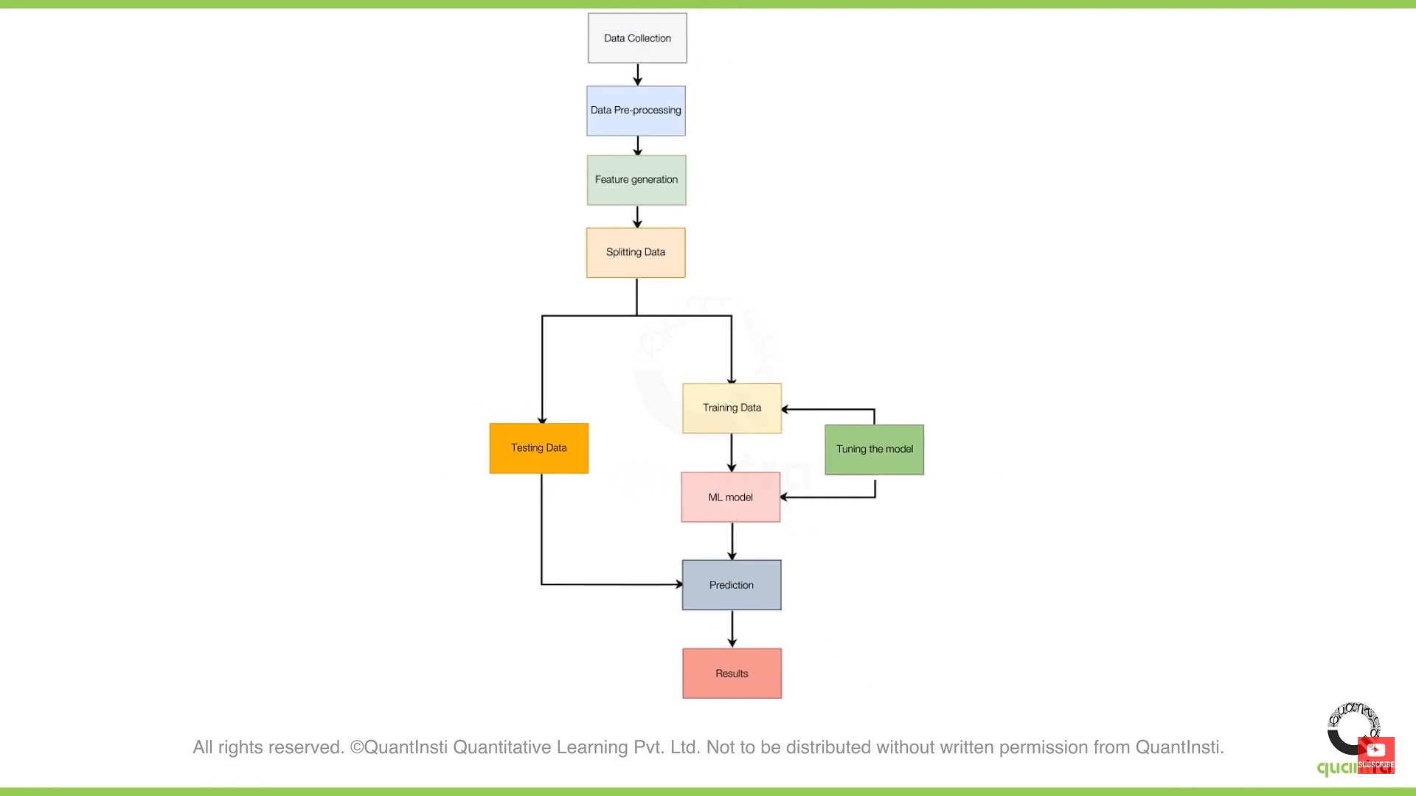

**Fig no: 1.1 Machine Learning Process Flow**

## 1.2.6 Machine Learning Model

A machine learning model is a mathematical representation of a real-world phenomenon, learned from data. It's like a smart algorithm that can make predictions or decisions based on new information it hasn't seen before. There are different types of machine learning models, like supervised learning where the model learns from labeled data, unsupervised learning where it finds patterns in unlabeled data, and reinforcement learning where it learns by trial and error. Regardless of the type, building a machine learning model involves collecting and preparing data, training the model, evaluating its performance, and then deploying it for use. Through this process, developers create models that can help solve complex problems and make informed decisions in various domains, from healthcare to finance to transportation.

**1.3 Deep Learning**

Deep learning neural networks represent a powerful subset of artificial intelligence (AI) algorithms that have revolutionized various fields, including computer vision, natural language processing, and speech recognition. This essay aims to provide a comprehensive introduction to deep learning neural networks, covering their fundamental concepts, architectures, applications, and challenges.

Deep learning extends the capabilities of traditional neural networks by introducing multiple layers between the input and output layers. These additional layers allow neural networks to learn complex representations of data through a process called feature learning or representation learning. Deep learning architectures can automatically discover hierarchical patterns in data, making them highly effective for tasks involving large amounts of unstructured data.

**1.3.1 Applications of Deep Learning**

Deep learning finds applications across diverse domains, including:

* **Computer Vision**: Deep learning enables accurate object detection, image classification, and facial recognition in computer vision tasks. It powers technologies like self-driving cars, surveillance systems, and medical image analysis.
* **Natural Language Processing (NLP)**: Deep learning models are used for sentiment analysis, language translation, chatbots, and speech recognition. They enhance user experiences in virtual assistants, language translation apps, and social media sentiment analysis tools.
* **Healthcare**: Deep learning aids in medical image analysis, disease diagnosis, and personalized treatment planning. It assists radiologists in detecting abnormalities in X-rays, MRIs, and CT scans, improving diagnostic accuracy and patient outcomes.
* **Finance**: Deep learning algorithms are employed in fraud detection, algorithmic trading, risk assessment, and customer service automation. They analyze financial data to identify fraudulent transactions, optimize trading strategies, and enhance customer service interactions.
* **Autonomous Vehicles**: Deep learning powers perception systems in autonomous vehicles, enabling them to recognize objects, pedestrians, and traffic signs. It contributes to the development of self-driving cars, drones, and other autonomous vehicles by enhancing their ability to perceive and navigate the environment.

**Deep Learning Challenges and Future Directions**

**Challenges**

* **Data Complexity:** Handling large-scale and high-dimensional datasets required for training deep learning models.
* **Interpretability**: Addressing the black-box nature of deep learning models to enhance understanding and trust.
* **Overfitting**: Mitigating the risk of overfitting, where models memorize noise in the training data instead of learning meaningful patterns.
* **Computational Resources:** Dealing with the computational demands of training deep neural networks, which often require significant processing power and memory.
* **Transfer Learning:** Improving techniques for transferring knowledge learned from one task or domain to another to reduce the need for extensive labeled data.

**Future Directions**

* **Interpretable Deep Learning**: Advancing methods to make deep learning models more interpretable and explainable.
* **Few-Shot Learning:** Exploring techniques to train deep learning models with limited labeled data, enabling them to generalize better.
* **Self-Supervised Learning:** Investigating self-supervised learning approaches that leverage unlabeled data to pretrain deep learning models.
* **Lifelong Learning:** Developing algorithms that can continually learn and adapt to new tasks and environments over time.
* **Hardware Optimization:** Designing specialized hardware architectures optimized for deep learning tasks to improve efficiency and scalability.

**1.3.2 Artificial Neural Network**

Artificial Neural Networks (ANNs) have become a cornerstone in artificial intelligence and machine learning, transforming fields like computer vision, natural language processing, and robotics. This essay will explore the intricacies of ANNs, including their architecture, functioning, applications, and future prospects.

At their core, ANNs are computational models inspired by the human brain's structure and functioning. They consist of interconnected nodes, or neurons, organized in layers, including an input layer, one or more hidden layers, and an output layer. Neurons receive input signals, process them through activation functions, and transmit the output to subsequent layers.

The strength of ANNs lies in their ability to learn from data. Through a process called training, ANNs adjust the weights of connections between neurons to minimize the difference between predicted and actual outputs. This learning is facilitated by optimization algorithms like gradient descent, which iteratively update weights to minimize the loss function.

ANNs find diverse applications across healthcare, finance, autonomous vehicles, speech recognition, and more. Despite their successes, ANNs face challenges such as the need for large labeled datasets and the risk of overfitting. Advancements in regularization techniques, data augmentation, and model architectures are needed to address these challenges and unlock the full potential of ANNs.

Looking ahead, the future of ANNs is promising, with ongoing research exploring novel architectures like transformer networks and neuroevolutionary algorithms. As ANNs continue to evolve, their capacity to drive innovation and solve complex real-world problems is poised for exponential growth.

**1.3.3 Neural Network Approach**

The neural network approach, a cornerstone of artificial intelligence and machine learning, has revolutionized the way we solve complex problems across various domains. This essay will provide a comprehensive overview of the neural network approach, covering its fundamentals, architectures, training techniques, applications, and future prospects.

**Fundamentals of Neural Networks**

At its core, a neural network is a computational model inspired by the structure and functioning of the human brain. It consists of interconnected nodes, or artificial neurons, organized in layers. The three main types of layers include:

* **Input Layer:** Neurons in the input layer receive the initial data or features.
* **Hidden Layers:** These layers, which may vary in number, extract hierarchical representations of the input data through weighted connections and activation functions.
* **Output Layer:** Neurons in the output layer produce the final predictions or classifications based on the information learned by the hidden layers.

**Architectures of Neural Networks**

Neural networks come in various architectures, each suited for specific tasks and data types:

* **Feedforward Neural Networks (FNNs):** In FNNs, information flows in one direction, from input to output, without any feedback loops. They are commonly used for tasks such as classification and regression.
* **Recurrent Neural Networks (RNNs):** RNNs include feedback connections, allowing them to exhibit dynamic temporal behaviour. They are well-suited for sequential data processing tasks like natural language processing and time series prediction.
* **Convolutional Neural Networks (CNNs):** CNNs are specialized for processing grid-like data, such as images. They leverage convolutional layers to automatically learn spatial hierarchies of features, making them highly effective in computer vision tasks.
* **Generative Adversarial Networks (GANs):** GANs consist of two neural networks, a generator and a discriminator, which are trained adversarially to generate realistic synthetic data. They have applications in image generation, style transfer, and data augmentation.

**Training Techniques**

Training neural networks involves optimizing their parameters (weights and biases) to minimize a loss function, which quantifies the difference between predicted and actual outputs. Key training techniques include:

* **Backpropagation:** Backpropagation is a method for computing gradients of the loss function with respect to the network's parameters. It enables efficient optimization using gradient-based optimization algorithms like stochastic gradient descent.
* **Regularization:** Techniques such as L1/L2 regularization, dropout, and batch normalization are used to prevent overfitting and improve the generalization of neural networks.
* **Transfer Learning:** Transfer learning involves reusing pre-trained neural network models and fine-tuning them on new tasks or datasets. This approach is particularly useful when labelled data is scarce.

**Applications of Neural Networks**

Neural networks have a wide range of applications across industries and domains:

Computer Vision: CNNs have revolutionized computer vision tasks such as image classification, object detection, image segmentation, and facial recognition.

* **Natural Language Processing (NLP):** RNNs and transformer-based architectures like BERT and GPT have significantly advanced tasks such as machine translation, sentiment analysis, and text generation.
* **Healthcare:** Neural networks are used for medical image analysis, disease diagnosis, drug discovery, personalized treatment recommendation, and healthcare management.
* **Finance:** In finance, neural networks power algorithmic trading systems, fraud detection algorithms, credit risk assessment models, and stock price prediction.
* **Autonomous Systems**: Neural networks play a crucial role in autonomous vehicles for perception, decision-making, and control tasks.

**Future Prospects**

The future of the neural network approach is promising, with ongoing research and development in several areas:

* **Continual Learning:** Improving the ability of neural networks to learn continuously from streaming data without catastrophic forgetting.
* **Explainable AI:** Enhancing the interpretability and transparency of neural network models to enable better understanding and trust.
* **Neuromorphic Computing:** Developing hardware architectures inspired by the brain's structure and functioning to achieve greater efficiency and scalability.
* **Hybrid Models:** Integrating neural networks with symbolic reasoning and probabilistic graphical models to combine the strengths of different approaches.

## 1.3.4 Convolutional Neural Network (CNN)

A Convolutional Neural Network (CNN) is a sophisticated type of deep learning algorithm tailored for processing visual data, like images. CNNs comprise layers that detect intricate features within images through convolution operations, reducing computational complexity with subsequent pooling layers, and culminating in fully connected layers for classification or prediction. Their notable advantage lies in autonomously learning complex hierarchical representations from raw data, eliminating the need for manual feature engineering. CNNs have revolutionized tasks such as image recognition, object detection, and medical image analysis, establishing them as pivotal tools across diverse domains, including healthcare, autonomous driving, and robotics.

## 1.3.5 Convolutional Neural Network Process Flow

* **Input Processing**: Raw input images are initially preprocessed to ensure uniformity and compatibility within the network.
* **Convolutional Layers**: The preprocessed images are passed through a series of convolutional layers, each of which applies convolution operations to detect features like edges, textures, and patterns within the images.
* **Activation Function**: After each convolution operation, an activation function, typically ReLU (Rectified Linear Unit), introduces non-linearity to the network, enabling it to learn more complex relationships in the data.
* **Pooling Layers**: Following the convolutional layers, pooling layers are employed to reduce the spatial dimensions of the feature maps while retaining the most important information. This reduces computational complexity and helps prevent overfitting.
* **Flattening**: The resulting feature maps are then flattened into a one-dimensional array to prepare for input into the fully connected layers.
* **Fully Connected Layers**: These layers integrate the flattened features and perform operations to learn higher-level abstractions from the extracted features. This stage enables the network to understand the relationships between different features and make predictions or classifications.
* **Softmax Activation**: In classification tasks, the output layer typically employs the softmax activation function to produce a probability distribution over the classes, ensuring that the predicted probabilities sum up to one.
* **Loss Function**: During training, the network's performance is evaluated using a loss function, such as categorical cross-entropy for classification tasks, which measures the difference between predicted and actual outputs.
* **Optimization**: The Adam optimizer is commonly used to minimize the loss function and update the network's parameters iteratively. Adam combines ideas from momentum optimization and RMSprop to adaptively adjust learning rates for each parameter.
* **Training**: The entire network is trained using a dataset with known labels, where the network adjusts its parameters iteratively through techniques like backpropagation and gradient descent using the Adam optimizer to minimize the loss function.
* **Evaluation**: Once trained, the network is evaluated on a separate test dataset to assess its performance and generalization ability.
* **Fine-Tuning**: Optionally, the network may undergo fine-tuning, where hyperparameters are adjusted, or additional layers are added or removed to improve performance on specific tasks or datasets.

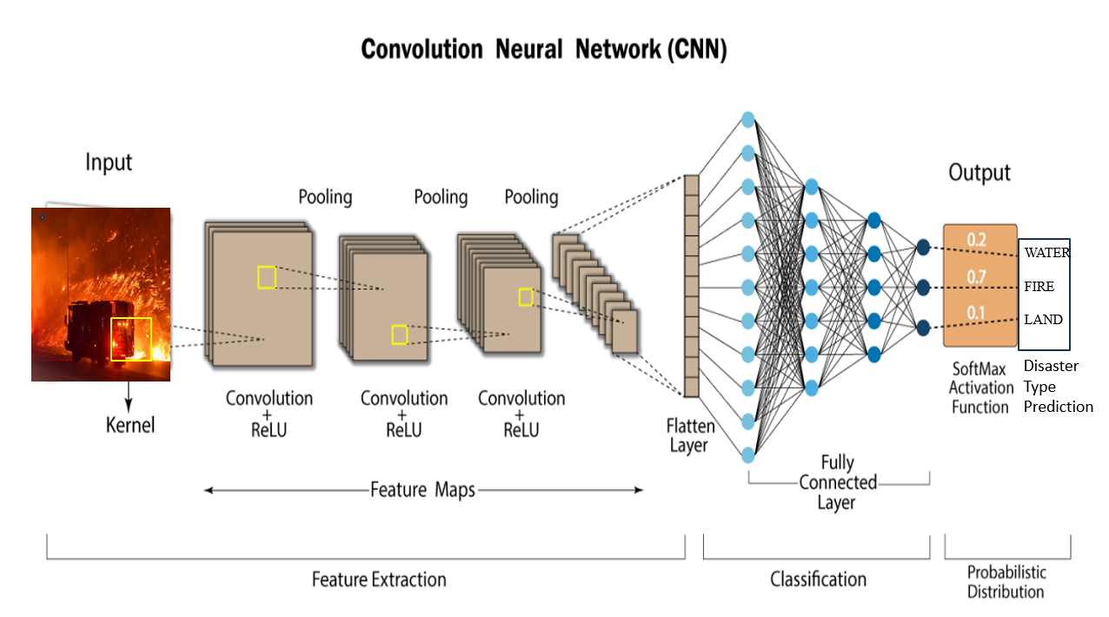

**Fig no: 1.2 Convolutional Neural Network**

**2. LITERATURE SURVEY**

**2.1 Introduction**

One significant stride in leveraging cutting-edge technology for effective disaster monitoring and detecting the Disaster. This initiative harnesses advanced models like Convolutional Neural Networks (CNNs) to classify photos, enabling swift identification types of disaster. What sets this project apart is distinguishes our disaster detection system is its innovative approach and advanced technology. Unlike traditional methods that may rely on manual observation or limited sensor networks, our system harnesses the power of Convolutional Neural Networks (CNNs) and machine learning techniques for accurate and efficient disaster detection. This cutting-edge technology allows our system to analyze complex data patterns and adapt to diverse disaster scenarios, ensuring swift and reliable detection.

## 

## 2.2 Problem Statement

When compared to Convolutional Neural Networks (CNNs), Random Forests lack the innate ability to capture spatial relationships within images, often necessitating manual feature engineering for image classification tasks. Additionally, Random Forests may encounter scalability issues when dealing with large-scale image datasets, while CNNs excel in handling complex data and automatic feature learning capabilities.

# 2.2.1 Existing System

In the existing disaster detection system, we use a Random Forest model to recognize images. This model sorts images into different types of disasters, helping us understand what's happening visually. By combining the knowledge of many decision trees, the system gets better at figuring out and classifying disasters quickly and accurately from pictures. This use of Random Forests makes our system better at spotting different types of disasters visually.

## 2.2.2 Proposed System

In our proposed disaster detection system, Convolutional Neural Networks (CNNs) are pivotal for image detection, categorizing images into different disaster types by learning hierarchical features. Their adeptness in discerning intricate patterns improves the accuracy of identifying specific disaster scenarios. Additionally, CNNs address overfitting concerns through techniques like dropout and pooling layers, ensuring robust performance. Their efficiency in processing image data suits real-time applications, and their layered architecture enhances interpretability compared to Random Forests. Excelling in handling high-dimensional image data, CNNs enhance our disaster detection capabilities.

## 2.3 Requirement Elicitation

In developing a disaster detection system with Convolutional Neural Networks (CNNs), understanding stakeholder needs is vital. This involves collaborating with users and experts to gather requirements and analyzing existing systems and disaster detection domains. To ensure user satisfaction, we create prototypes to visualize system functionality and gather feedback. Based on these insights, we document functional and non-functional requirements, ensuring fast and efficient image processing, improved accuracy, and efficient resource utilization. Validation with stakeholders ensures alignment and guides system development to effectively meet user needs. This rigorous process ensures the system is tailored to user requirements, promoting its success and usability. Additionally, robustness is ensured to enhance reliability and effectiveness.

## Identifying Actors

In this Disaster Detection System there are two actors:

* **Users**: Users interact with the system to input data, view results, and adjust settings as needed.
* **System**: The system processes input data, performs analysis, and generates output based on predefined algorithms and parameters.

## Identifying Scenarios

In our disaster detection system, the process commences with the user uploading an image. Subsequently, the system initiates preprocessing of the image, which involves essential tasks such as resizing and converting it into an array of pixels. This preprocessed image is then inputted into the Convolutional Neural Network (CNN) model. Leveraging its capabilities, the CNN model meticulously processes the image, analyzing it to calculate the probability of a disaster being present. Upon completion of the analysis, the system presents the prediction to the user.

## Identifying Use Cases

Once developers and users decide on the scenarios, a set of use cases is developed to comprehensively capture the functionalities and interactions of the disaster detection system.

## Refining Use Cases

## During this activity, developers ensure that the requirements specifications are detailed for each use case in the disaster detection system, outlining the expected behavior of the system under normal conditions.

## Identifying Relationships among Use Cases

In the disaster detection system, the relationship between the user and the system is pivotal. The user initiates actions such as uploading images and receiving predictions, while the system processes data, analyzes images, and delivers feedback to the user. This interaction forms the foundation of the relationship between the user and the system across all use cases, ensuring effective functionality and user engagement.

## Actors

## Actors are external entities that interact with the system. Actors typically include a user role or another system. They have a unique names and descriptions.

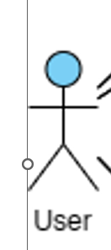 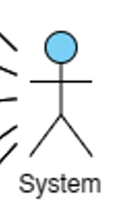

In this project the two actors are User and System:

## Actor Roles

User -- --Load the Model

--Upload the Image

System-- --Preprocess the Image

--Calculate the Probability

--Generate Prediction

--Display Prediction

### 2.4 Non-Functional Requirements

Developers, users, and clients collaborate to agree on various aspects, including system performance requirements, documentation standards, resource availability, security measures, and quality assurance protocols. This collaborative effort ensures that the disaster detection system operates within specified constraints and meets the needs and expectations of all stakeholders involved in the project.

**Performance**

* Fast and efficient image processing.
* Low-latency inference for timely classification.
* High accuracy in classifying diverse images.
* Efficient utilization of computational resources.

**Robustness**

* Ensure reliability and effectiveness
* Enhance overall longevity of the system.

**Usability**

* Intuitive user interface for ease of operation.

## Functional Requirements

**Image Input**

* Accept images in various formats (JPEG, PNG, etc.).
* Support file upload for uploading images.
* Allowing compatible images above the minimum resolution of 400*400.
* Allowing compatible images up to a maximum of 4K resolution**.**

**Preprocessing**

* Preprocess images for normalization and resizing.

**Feature Extraction**

* Extract relevant features using techniques like CNN.

**Classification**

* Enable real-time classification for classifying new images.

## 2.5.1 Hardware Requirements

The Minimum hardware requirements to run this system are:

* **Processor:** A Dual-core processor
* **Ram:** 4 GB
* **System Type:** 64/32-bit Operating System
* **Hard Disk:** 128GB HDD or SDD
* **Monitor:** User choice
* **Keyboard:** Standard 102 keys
* **Mouse:** Standard

## Software Requirements

The Minimum software requirements to run this system are:

* **Operating System:** Windows 10 or above
* **Server-side Script:** Python
* **IDE:** Visual Studio Code (VS Code)
* **Libraries Used:** Pandas, Scikit-learn and Keras
* **Model Persistence:** Pickle.
* **GUI Development:** Tkinter
* **Machine Learning Frameworks:** CNN

# 3. INTRODUCTION TO PYTHON

## 3.1 Introduction

Python is a versatile and easy-to-learn programming language renowned for its simplicity and readability. Developed by Guido van Rossum, Python's clear syntax and extensive library support make it an ideal choice for a wide range of applications, including web development, data analysis, artificial intelligence, and scientific computing. Its vibrant community and rich ecosystem of libraries and frameworks contribute to its popularity among developers worldwide.

**3.1.1 Advantages of Python**

Python's versatility and ease of use make it an ideal language for a wide range of applications, from web development and data analysis to artificial intelligence and scientific computing. Its extensive standard library and vibrant community support ensure that developers have access to a wealth of resources and expertise, facilitating rapid development and problem-solving.

* **Readability and Simplicity:** Python's clear and concise syntax enhances code readability and reduces development time.
* **Versatility:** Python is suitable for various applications, including web development, data analysis, machine learning, and automation.
* **Large Standard Library:** Python's extensive standard library provides modules for diverse tasks, enabling rapid application development.
* **Interpreted and Interactive:** Python's interpreted nature allows for interactive development and experimentation.
* **Extensive Third-Party Libraries:** Python's vast ecosystem of third-party libraries accelerates development and provides solutions for various domains.
* **Community Support:** Python has a large and active community, ensuring continuous support, documentation, and improvement.
* **Integration Capabilities:** Python seamlessly integrates with other languages, enhancing code reusability and interoperability.
* **Scalability:** Python is scalable, suitable for projects of any size and complexity.
* **Open Source:** Python is open-source and free to use, fostering collaboration and innovation within the community.

## 3.1.2 Characteristics of Python

Python is a high-level, interpreted, interactive and object-oriented scripting language. Python is designed to be highly readable. It uses English keywords frequently where as other languages use punctuation, and it has fewer syntactical constructions than other languages.

* **Readability and Maintainability:** Python emphasizes readability with its clean and concise syntax, making it easy to write and understand code. This readability reduces the likelihood of errors and simplifies code maintenance and debugging, especially in collaborative projects.
* **Strong Community and Ecosystem:** Python has a vast ecosystem of third-party libraries and frameworks developed and maintained by its active community. These libraries cover a wide range of domains, including web development, data analysis, machine learning, and more, empowering developers to leverage existing solutions and accelerate development.
* **Scalability:** Python's scalability allows it to be used for both small-scale scripts and large-scale applications. Its modular design, combined with tools like virtual environments and package managers, enables seamless scalability as projects grow in complexity and size.
* **Portability:** Python's portability extends beyond operating systems to different hardware architectures and deployment environments. Whether deploying applications on local servers, cloud platforms, or embedded systems, Python offers flexibility and compatibility across various environments.
* **Integration Capabilities:** Python's flexibility extends to its integration capabilities with other languages and systems. Through interfaces like CPython, Jython, and IronPython, developers can seamlessly integrate Python with languages like C/C++, Java, and .NET, leveraging existing codebases and libraries.
* **Rapid Prototyping:** Python's ease of use and high-level abstractions facilitate rapid prototyping and experimentation. With minimal boilerplate code and quick feedback loops, developers can iterate quickly on ideas and concepts, speeding up the development cycle.
* **Community Support and Documentation:** Python's strong community support extends to comprehensive documentation, tutorials, and online resources. Whether beginners seeking to learn the language or experienced developers facing challenges, Python's supportive community provides valuable resources and assistance.

## New Approach for building window Software

Combining object-oriented programming principles with Tkinter represents a powerful strategy for crafting user-friendly windowed interfaces in Python. By leveraging object-oriented design, developers can organize their code into reusable and modular components, enhancing maintainability and scalability. Tkinter, as the GUI toolkit of choice, seamlessly integrates with object-oriented Python code, allowing developers to create interactive and visually appealing user interfaces. Through the use of classes and objects, developers can encapsulate GUI elements such as windows, buttons, and input fields, enabling easier manipulation and customization. This approach not only simplifies the development process but also promotes code readability and facilitates collaborative development efforts. Ultimately, the synergy between object-oriented programming and Tkinter empowers developers to create sophisticated and user-friendly desktop applications that meet the needs of modern users.

## 3.1.3 Applications of Python

As mentioned before, Python is one of the most widely used language.

I'm going to list few of them here:

**Easy-to-learn** − Python has few keywords, simple structure, and a clearly defined syntax.

This allows the student to pick up the language quickly.

**Easy-to-read** − Python code is more clearly defined and visible to the eyes.

**Easy-to-maintain** − Python's source code is fairly easy-to-maintain.

**A broad standard library** − Python's bulk of the library is very portable and cross

platform compatible on UNIX, Windows, and Macintosh.

**Interactive Mode** − Python has support for an interactive mode which allows interactive

testing and debugging of snippets of code.

**Portable** − Python can run on a wide variety of hardware platforms and has the same

interface on all platforms.

**Extendable** − You can add low-level modules to the Python interpreter. These modules

enable programmers to add to or customize their tools to be more efficient.

**Databases** − Python provides interfaces to all major commercial databases.

**GUI Programming** − Python supports GUI applications that can be created and ported to

many system calls, libraries and windows systems, such as Windows MFC, Macin tosh,

and the X Window system of Unix.

**Scalable** − Python provides a better structure and support for large programs than shell

scripting.

**3.1.4 Object Oriented Programming in Python**

Object-oriented programming (OOP) is a programming paradigm that organizes software design around objects and data rather than actions and logic. In OOP, objects are instances of classes, which encapsulate data for the object and methods, which are functions associated with the object's behavior.

* **Class:** A class is a blueprint for creating objects. It defines the attributes (data) and methods (functions) that all objects created from the class will have. Classes are created using the class keyword.
* **Object (Instance):** An object is an instance of a class. It is a concrete realization of the class blueprint, with its own unique data and behavior. Objects are created by calling the class as if it were a function.
* **Attributes:** Attributes are variables that belong to a class or an object. They represent the state of the object. Attributes can be accessed using dot notation.
* **Methods:** Methods are functions defined within a class. They define the behavior of the objects created from the class. Methods can access and modify the object's attributes.
* **Constructor (__init__):** The constructor is a special method called when an object is created. It initializes the object's attributes. In Python, the constructor method is named __init__.
* **Encapsulation:** Encapsulation is the bundling of data and methods that operate on the data within a single unit (class). It hides the internal state of an object and only exposes the necessary functionality through methods.
* **Inheritance:** Inheritance is the mechanism by which one class can inherit attributes and methods from another class. The class being inherited from is called the base class or superclass, and the class inheriting from it is called the derived class or subclass.
* **Polymorphism:** Polymorphism allows objects of different classes to be treated as objects of a common superclass. It enables methods to behave differently based on the object they operate on.

**3.1.5 Libraries and Packages**

**Data Manipulation and Analysis Libraries**

**NumPy**

NumPy, short for Numerical Python, is a fundamental package for numerical computing in Python. It provides support for multi-dimensional arrays and matrices, along with a collection of mathematical functions to operate on these arrays efficiently. NumPy is a cornerstone library in the Python scientific computing ecosystem and is extensively used in fields such as machine learning, data science, physics, engineering, and finance.

**Features and Component of NumPy**

* **Arrays**: The central data structure in NumPy is the ndarray (N-dimensional array), which represents arrays of homogeneous data types. These arrays can have any number of dimensions and can store elements of the same data type, such as integers, floats, or complex numbers.
* **Vectorized Operations**: NumPy provides support for vectorized operations, allowing mathematical operations to be performed on entire arrays without the need for explicit looping in Python. This enables efficient and concise code for numerical computations, which is essential for high-performance computing.
* **Universal Functions (ufuncs)**: NumPy includes a large collection of universal functions, or ufuncs, which are functions that operate element-wise on arrays. These ufuncs enable efficient computation of mathematical functions like trigonometric functions, exponential and logarithmic functions, and more, across entire arrays.
* **Broadcasting**: NumPy's broadcasting rules allow arrays of different shapes to be combined in arithmetic operations. When operating on arrays of different shapes, NumPy automatically broadcasts the arrays to perform the operation efficiently, making it easier to write code that works with arrays of different sizes.
* **Indexing and Slicing**: NumPy provides powerful indexing and slicing capabilities for accessing and manipulating elements of arrays. This includes basic slicing, advanced indexing, boolean indexing, and more, allowing for flexible manipulation of array data.
* **Random Number Generation**: NumPy includes a random module that provides functions for generating random numbers and random arrays. These functions are useful for various tasks such as random sampling, shuffling data, generating random distributions, and seeding random number generators for reproducibility.
* **Linear Algebra Operations**: NumPy includes a submodule called numpy.linalg that provides a wide range of linear algebra operations, such as matrix multiplication, matrix decomposition (e.g., LU decomposition, QR decomposition), matrix inversion, eigenvalue and eigenvector computation, and more.
* **Integration with Other Libraries**: NumPy integrates seamlessly with other Python libraries in the scientific computing ecosystem, such as SciPy (Scientific Python), pandas (data analysis library), matplotlib (plotting library), and scikit-learn (machine learning library). Many of these libraries build on top of NumPy arrays to provide additional functionality.

**Pandas**

Pandas is a powerful and widely-used open-source Python library for data manipulation and analysis. It provides easy-to-use data structures, such as DataFrame and Series, which allow users to efficiently work with structured data. Pandas is built on top of NumPy and integrates seamlessly with other libraries in the Python ecosystem, making it a popular choice for data scientists, analysts, and developers.

**Features of Pandas**

* **DataFrame**: The DataFrame is a two-dimensional labeled data structure with columns of potentially different data types. It resembles a spreadsheet or SQL table and is the primary object for data manipulation in Pandas.
* **Series**: The Series is a one-dimensional labeled array capable of holding data of any type. It is often used for representing columns in a DataFrame or as standalone data structures.
* **Data Input/Output**: Pandas provides functions to read and write data from various file formats, including CSV, Excel, JSON, SQL databases, and more. This makes it easy to work with data from different sources.
* **Data Manipulation**: Pandas offers a rich set of functions for data manipulation, including indexing, slicing, filtering, grouping, aggregating, merging, joining, and reshaping data. These operations allow users to clean, transform, and analyze datasets efficiently.
* **Missing Data Handling**: Pandas provides robust support for handling missing or incomplete data, allowing users to easily identify, remove, fill, or interpolate missing values in their datasets.
* **Time Series Analysis**: Pandas includes tools for working with time series data, such as date/time indexing, resampling, frequency conversion, and rolling window calculations. This makes it well-suited for analyzing time-stamped data.
* **Data Visualization**: Although Pandas itself does not provide visualization capabilities, it integrates seamlessly with visualization libraries like Matplotlib and Seaborn.
* **High Performance**: Pandas is designed for high performance and efficiency, with many operations optimized for speed. It leverages NumPy under the hood for fast numerical computations and supports parallel processing for large-scale data processing.

**Fundamental Python Libraries**

**Python - GUI Programming (Tkinter)**

Python provides various options for developing graphical user interfaces (GUIs). Most important are listed below.

* **Tkinter** − Tkinter is the Python interface to the Tk GUI toolkit shipped with Python. We would look this option in this chapter.
* **wxPython** − This is an open-source Python interface for wxWindows [http://wxpy-](http://wxpy-/)

thon.org.

* **JPython** − JPython is a Python port for Java which gives Python scripts seamless ac-

cess to Java class libraries on the local machine [http://www.jython.org.](http://www.jython.org/)

* There are many other interfaces available, which you can find them on the net.

## Tkinter Programming

Tkinter is the standard GUI library for Python. Python when combined with Tkinter provides a fast and easy way to create GUI applications. Tkinter provides a powerful object- oriented interface to the Tk GUI toolkit.

Creating a GUI application using Tkinter is an easy task. All you need to do is perform the following steps −

* Import the Tkinter module.
* Create the GUI application main window.
* Add one or more of the above-mentioned widgets to the GUI application.

## Tkinter Widgets

Tkinter provides various controls, such as buttons, labels and text boxes used in a GUI application. These controls are commonly called widgets.

There are currently 15 types of widgets in Tkinter. We present these widgets as well as a brief description in the following table –

## Button: The Button widget is used to display buttons in your application.

## Canvas: The Canvas widget is used to draw shapes, such as lines, ovals, polygons and rec- tangles, in your application.

## Check button: The Check button widget is used to display a number of options as checkboxes. The user can select multiple options at a time.

## Entry: The Entry widget is used to display a single-line text field for accepting values from a user.

## Frame: The Frame widget is used as a container widget to organize other widgets.

## Label: The Label widget is used to provide a single-line caption for other widgets. It can also contain images.

## List box: The List box widget is used to provide a list of options to a user.

## Menu button: The Menu button widget is used to display menus in your application.

## Menu: The Menu widget is used to provide various commands to a user. These commands are contained inside Menu button.

## Message: The Message widget is used to display multiline text fields for accepting values from a user.

**Sys**

The **sys** module in Python, part of the standard library, provides crucial access to system-specific parameters and functions essential for Python runtime management. It enables tasks such as accessing command-line arguments (**sys.argv**), manipulating module search paths (**sys.path**), and identifying the platform running Python (**sys.platform**). Additionally, it offers utilities for standard I/O operations (**sys.stdin**, **sys.stdout**, **sys.stderr**) and allows graceful termination of scripts with optional exit status codes using **sys.exit()**. The module also provides access to information about the Python interpreter version (**sys.version** and **sys.version_info**), aiding in compatibility checks and debugging. Overall, **sys** is indispensable for system-level interactions and runtime environment management within Python scripts.

**OS (Operating System)**

The operating system (OS) is a fundamental component of modern computing systems, serving as the intermediary between hardware and software. It manages the resources of a computer system, provides a user interface, and facilitates the execution of applications. In this essay, we will explore the role of the operating system, its key components, and its significance in the world of computing.

**Role of Operating System**

* **Resource Management**: The OS manages hardware resources such as the CPU, memory, disk storage, and peripheral devices. It allocates these resources efficiently among different processes and users, ensuring that they are utilized effectively.
* **Process Management**: The OS oversees the execution of processes, which are instances of running programs. It schedules processes for execution, switches between them to allow multitasking, and provides mechanisms for inter-process communication and synchronization.
* **Memory Management**: The OS manages system memory, allocating memory to processes when needed and reclaiming it when processes are terminated. It ensures that each process has access to the memory it requires without interfering with other processes.
* **File System Management**: The OS provides a file system that organizes and manages files stored on disk or other storage devices. It handles file creation, deletion, reading, and writing, and provides mechanisms for organizing files into directories and managing file permissions.
* **Device Management**: The OS interacts with peripheral devices such as keyboards, mice, printers, and network interfaces. It provides device drivers that enable communication between software applications and hardware devices, abstracting the low-level hardware details.
* **User Interface**: The OS provides a user interface through which users can interact with the computer system. This can be a command-line interface (CLI), a graphical user interface (GUI), or a combination of both. The user interface allows users to run applications, manage files, configure system settings, and perform other tasks.
* **Security**: Security is a crucial aspect of any operating system. The OS provides mechanisms for user authentication, access control, data encryption, and protection against malware and other security threats.

**Components of Operating System**

* **Kernel**: The core component responsible for managing system resources, providing essential services, and facilitating communication between hardware and software.
* **File System**: Manages the organization, storage, and retrieval of files on storage devices, ensuring data integrity and access control.
* **Device Drivers**: Facilitate communication between the OS and hardware devices, abstracting hardware details and providing a standardized interface.
* **User Interface**: Allows users to interact with the OS and applications, typically through a graphical user interface (GUI) or a command-line interface (CLI).
* **Process Management**: Manages the creation, scheduling, execution, and termination of processes or tasks running on the system, ensuring efficient resource utilization.
* **Memory Management**: Allocates and deallocates system memory (RAM) to processes, manages virtual memory, and prevents conflicts between processes.
* **Security Subsystem**: Ensures the security of system resources and user data through mechanisms such as authentication, access control, encryption, and intrusion detection.

**Image Processing Library**

**Pillow**

Pillow is a Python Imaging Library (PIL) that serves as a versatile tool for opening, manipulating, and saving various image file formats. It offers comprehensive support for image processing tasks such as resizing, cropping, rotating, filtering, and enhancing images. With Pillow, users can effortlessly load images from files or create new images programmatically, with compatibility for popular formats like JPEG, PNG, GIF, BMP, and TIFF. Whether for web development, computer vision projects, digital art creation, or scientific visualization, Pillow provides both high-level APIs for common image manipulation tasks and low-level access to image data, making it an invaluable asset for image processing in Python.

**Modules in Pillow**

1. **Image Module (PIL.Image):**

* The Image module is the core module of Pillow, providing functions and classes for working with images.
* It includes classes like Image for representing images, and functions like open for opening image files and fromarray for creating images from arrays.

1. **ImageDraw Module (PIL.ImageDraw):**

* The ImageDraw module provides tools for drawing shapes, text, and other graphics on images.
* It includes classes like ImageDraw for drawing on images, and functions like Draw.text for adding text to images.

1. **ImageFilter Module (PIL.ImageFilter):**

* The ImageFilter module contains various image filters and enhancement algorithms.
* It includes classes like Filter for defining custom filters, and predefined filters like BLUR and SHARPEN for blurring and sharpening images.

1. **ImageOps Module (PIL.ImageOps):**

* The ImageOps module provides operations for image manipulation and enhancement.
* It includes functions like autocontrast for enhancing image contrast, mirror for flipping images, and crop for cropping images.

1. **ImageEnhance Module (PIL.ImageEnhance):**

* The ImageEnhance module offers tools for enhancing image properties such as brightness, contrast, and color balance.
* It includes classes like Enhance for enhancing specific properties, and functions like Enhance.Contrast for adjusting image contrast.

1. **ImageChops Module (PIL.ImageChops):**

* The ImageChops module provides operations for performing arithmetic and logical operations on images.
* It includes functions like add for adding images, multiply for multiplying images, and difference for computing the absolute difference between images.

1. **ImageFile Module (PIL.ImageFile):**

* The ImageFile module contains utilities for working with image files, such as parsers and handlers.
* It includes classes like Parser for parsing image data, and functions like ImageFile.Parser() for creating a parser object.

1. **ImageTk Module (PIL.ImageTk):**

* The ImageTk module provides support for using Pillow images with Tkinter, a popular GUI toolkit for Python.
* It includes functions like ImageTk.PhotoImage for creating Tkinter-compatible image objects from Pillow images, enabling seamless integration of images into Tkinter-based applications.

**Machine Learning Libraries**

**TensorFlow**

TensorFlow is a powerful open-source machine learning framework developed by Google. It's renowned for its flexibility, scalability, and extensive community support. With TensorFlow, developers can build and train various machine learning models, including neural networks, for a wide range of tasks such as image classification, natural language processing, and reinforcement learning.

One of TensorFlow's key features is its computational graph paradigm. Users define a computational graph that represents the flow of data through the system. This graph defines the operations and dependencies between tensors, the primary data structure in TensorFlow. Once the graph is constructed, TensorFlow efficiently executes it on CPUs, GPUs, or even specialized hardware like TPUs, enabling high-performance computation.

TensorFlow provides a high-level API, TensorFlow Keras, which simplifies the process of building and training neural networks. Keras offers a user-friendly interface for defining, training, and evaluating models, making it accessible to both beginners and experts. Additionally, TensorFlow's extensive documentation and tutorials empower developers to quickly get started and delve deeper into advanced topics.

The ecosystem around TensorFlow is vast, with libraries and tools that extend its capabilities. TensorFlow Hub offers pre-trained models and modules for transfer learning, enabling developers to leverage the knowledge captured by models trained on large datasets. TensorFlow Extended (TFX) provides end-to-end machine learning pipelines for production deployment, ensuring scalability, reliability, and maintainability.

Moreover, TensorFlow's integration with other popular libraries and frameworks, such as TensorFlow Probability, TensorFlow Lite, and TensorFlow.js, further extends its applicability across different platforms and domains. Whether it's deploying models on mobile devices, running inference in the browser, or exploring probabilistic models, TensorFlow provides the tools and resources to turn ideas into reality.

In conclusion, TensorFlow revolutionizes the field of machine learning by offering a comprehensive framework for developing, training, and deploying models at scale.

**Keras**

Keras is a high-level neural networks API, written in Python and capable of running on top of TensorFlow, Theano, or CNTK. It provides a user-friendly interface for building, training, and deploying deep learning models with minimal code. Keras abstracts away much of the complexity of building neural networks, making it accessible to beginners while still offering flexibility and customization options for advanced users

**Key Features of Keras**

* **Simplicity:** Keras offers a simple and intuitive API that allows users to define neural network models using high-level building blocks such as layers, activations, optimizers, and loss functions. This simplicity makes it easy to experiment with different architectures and configurations.
* **Modularity:** Keras promotes a modular approach to building neural networks, where models are constructed by stacking layers on top of each other. This modular design facilitates the creation of complex architectures by combining different types of layers, including convolutional, recurrent, and dense layers.
* **Flexibility:** While Keras provides a high-level interface for building neural networks, it also offers flexibility and customization options for advanced users. Users can define custom layers, loss functions, and metrics, allowing them to tailor models to specific tasks and domains.
* **Compatibility:** Keras is designed to be compatible with other popular deep learning libraries such as TensorFlow, Theano, and Microsoft Cognitive Toolkit (CNTK). This compatibility allows users to seamlessly switch between backend engines without modifying their code.
* **Scalability:** Keras supports distributed training across multiple GPUs and CPUs, enabling users to scale their deep learning experiments to larger datasets and more powerful hardware.
* **Community Support:** Keras has a large and active community of users and developers who contribute to its development, provide support, and share resources such as tutorials, documentation, and pre-trained models.

**Modules in Keras**

1. **Models Module (keras.models):**
   * The models module provides functionalities for defining and working with deep learning models.
   * It includes functions like Sequential for creating sequential models and load_model for loading pre-trained models from disk.
2. **Preprocessing Module (keras.preprocessing.image):**
   * The preprocessing.image module offers tools for preprocessing image data before feeding it into deep learning models.
   * Functions like load_img and img_to_array are used to load images from disk and convert them into numerical arrays suitable for model input.
3. **Layers Module (keras.layers):**
   * The layers module contains various layer types that can be used to construct neural network architectures.
   * It includes classes like Conv2D for 2D convolutional layers and MaxPooling2D for max-pooling layers commonly used in convolutional neural networks (CNNs).
4. **Utils Module (keras.utils):**
   * The utils module provides utility functions for common tasks in deep learning, such as data preprocessing and model evaluation.
   * Functions like to_categorical are used for one-hot encoding categorical labels, while plot_model can be used to visualize model architectures.
5. **Losses Module (keras.losses):**
   * The losses module contains various loss functions that are used to quantify the difference between predicted and actual outputs during model training.
   * It includes functions like categorical_crossentropy for multi-class classification tasks and mean_squared_error for regression tasks.
6. **Optimizers Module (keras.optimizers):**
   * The optimizers module provides optimization algorithms that are used to update the parameters of a neural network during training.
   * Common optimizers include Adam, SGD (Stochastic Gradient Descent), and RMSprop.

**Scikit-learn**

Scikit-learn, often abbreviated as sklearn, is a comprehensive and widely-used machine learning library in Python. It's built on top of other Python libraries like NumPy, SciPy, and matplotlib, and is designed to be user-friendly, efficient, and extensible. Scikit-learn provides a wide range of machine learning algorithms and tools for data preprocessing, model selection, evaluation, and more.

**Key Aspects of Scikit-Learn**

* **Rich Collection of Algorithms:** Scikit-learn provides implementations of various machine learning algorithms for both supervised and unsupervised learning tasks. This includes algorithms for classification, regression, clustering, dimensionality reduction, feature selection, and more. Whether you're working on text data, image data, or tabular data, scikit-learn likely has a suitable algorithm for your task.
* **Efficient and Scalable:** Scikit-learn is optimized for performance and scalability. It's capable of handling large datasets efficiently, thanks to its integration with NumPy and SciPy, which provide fast numerical operations and data structures. Additionally, scikit-learn supports parallel processing, allowing certain computations to be distributed across multiple CPU cores for faster execution.
* **Extensibility and Interoperability:** Scikit-learn is designed to be modular and extensible. It provides a flexible framework for integrating custom algorithms, preprocessing techniques, and evaluation metrics. Moreover, scikit-learn interoperates well with other Python libraries and tools commonly used in the machine learning ecosystem, such as pandas for data manipulation and matplotlib for data visualization.
* **Documentation and Community Support:** Scikit-learn offers extensive documentation, including user guides, API references, and tutorials, making it easy to get started with the library. Additionally, scikit-learn has a vibrant community of users and contributors who actively participate in discussions, provide support, and contribute to the development of the library.

**Scikit-learn Modules**

* **sklearn.datasets:** This module provides utilities for loading datasets for practicing and benchmarking machine learning algorithms. It includes both toy datasets like Iris and digits, as well as real-world datasets like the famous Iris dataset, the Boston housing dataset, and more. These datasets are often used for experimenting with different algorithms and evaluating model performance.
* **sklearn.preprocessing**: This module contains various functions for preprocessing data before feeding it into machine learning models. Preprocessing steps can include scaling features to a similar range, normalizing data, encoding categorical variables, handling missing values, and more. The preprocessing module helps ensure that the data is in a suitable format for training machine learning models and can often improve model performance.
* **sklearn.feature_extraction**: This module provides functions for feature extraction from raw data, especially useful for text and image data. It includes methods like bag-of-words for text data, TF-IDF (Term Frequency-Inverse Document Frequency), and image feature extraction techniques like histogram of oriented gradients (HOG) or local binary patterns (LBP). These techniques are essential for transforming raw data into a format that machine learning models can understand.
* **sklearn.feature_selection**: This module offers methods for selecting the most relevant features from a dataset. Feature selection is crucial for improving model performance and reducing overfitting by eliminating irrelevant or redundant features. Techniques range from simple univariate methods to more sophisticated algorithms like recursive feature elimination (RFE) and feature importance ranking.
* **sklearn.model_selection**: This module provides tools for model selection and evaluation. It includes functions for cross-validation, hyperparameter tuning using techniques like grid search and randomized search, and splitting datasets into training and testing sets. Model selection is essential for choosing the best algorithm and tuning its parameters for optimal performance on unseen data.
* **sklearn.linear_model**: This module contains linear models for regression, classification, and other tasks. It includes algorithms like linear regression, logistic regression, ridge regression, LASSO (Least Absolute Shrinkage and Selection Operator), and elastic net. Linear models are widely used due to their simplicity, interpretability, and efficiency.
* **sklearn.tree** **and** **sklearn.ensemble**: These modules contain decision tree-based algorithms and ensemble methods. Decision trees are versatile models that can handle both classification and regression tasks, while ensemble methods like random forests, gradient boosting, and AdaBoost combine multiple models to improve predictive performance.
* **sklearn.svm**: This module contains support vector machine (SVM) algorithms for classification, regression, and outlier detection. SVMs are powerful supervised learning models used for both linear and non-linear tasks. They work by finding the optimal hyperplane that separates different classes in the feature space.
* **sklearn.cluster**: This module provides algorithms for clustering, including k-means, hierarchical clustering, DBSCAN (Density-Based Spatial Clustering of Applications with Noise), and more. Clustering is an unsupervised learning task used for grouping similar data points together based on their features.
* **sklearn.metrics**: This module contains functions for evaluating the performance of machine learning models. It includes metrics such as accuracy, precision, recall, F1-score, ROC curve, confusion matrix, and more. These metrics help assess how well a model is performing and compare different models' performance.

**Data Visualization Libraries**

**Matplotlib**

Matplotlib is a versatile plotting library in Python, widely used for creating static, interactive, and animated visualizations. Offering a diverse range of plot types, customization options, and support for multiple output formats, Matplotlib empowers users to generate publication-quality plots tailored to their specific needs. Its seamless integration with other Python libraries facilitates efficient data visualization and analysis workflows. Additionally, Matplotlib's interactive plotting capabilities enable users to explore and analyze complex datasets with ease. With extensive documentation and a rich gallery of example plots, Matplotlib serves as an invaluable resource for both beginners and experienced users, making it a go-to choice for data visualization tasks in Python.

**Threading**

The threading library in Python provides a way to run multiple threads (subprocesses of a process) concurrently within a single process. Threads allow programs to perform multiple tasks simultaneously, taking advantage of multi-core processors and improving overall performance. Here are the key components and concepts of the threading library in Python:

* **Thread:** A thread is the smallest unit of execution within a process. It represents a separate flow of control, allowing multiple tasks to run concurrently. Threads share the same memory space within a process and can communicate with each other easily.
* **Thread Class:** The thread class is provided by the threading module and is used to create and manage threads in Python programs. To create a new thread, you can subclass the Thread class and override the run() method with the code that you want the thread to execute.
* **Thread Function:** Alternatively, you can create a thread by passing a function to the Thread constructor. The provided function will be executed when the thread starts.
* **Starting a Thread:** Threads are started using the start() method, which initiates the execution of the **run()** method or the target function associated with the thread.
* **Joining Threads:** The join() method is used to wait for a thread to complete its execution. This method blocks the calling thread until the specified thread has finished.

**Time**

The time module in Python provides various functions to work with time-related tasks, including measuring time, formatting time, and performing conversions between different time representations. Here's an overview of the key functionalities offered by the time module:

1. **Time Access**:
   * **time()**: Returns the current time in seconds since the epoch (January 1, 1970, 00:00:00 UTC) as a floating-point number.
   * **gmtime()**: Returns the current time in UTC as a named tuple containing year, month, day, hour, minute, second, etc.
   * **localtime()**: Returns the current time in local time zone as a named tuple.
   * **mktime()**: Converts a time tuple to seconds since the epoch.
2. **Time Formatting**:
   * **asctime()**: Converts a time tuple or floating-point number to a string representing the local time in a human-readable format.
   * **ctime()**: Converts a time in seconds since the epoch to a string representing the local time in a human-readable format.
   * **strftime()**: Formats a time tuple or struct_time object according to a format string.
3. **Sleeping and Timing**:
   * **sleep()**: Suspends the execution of the current thread for a specified number of seconds.
   * **perf_counter()**: Returns the value of a high-resolution performance counter, useful for measuring short durations accurately.
   * **process_time()**: Returns the accumulated CPU time of the current process, excluding time spent sleeping.

**4. UML MODELING**

**4.1 Introduction To UML**

UML is a standard language for specifying, visualizing, constructing, and documenting the artifacts of software system. UML was created by the Object Management Group (OMG) and UML 1.0 specification drift was proposed to the OMG in January 1997.

OMG is continuously making efforts to create a truly industry standard.

• UML stands for Unified Modeling Language.

• UML is different from the other common programming language such as C++, java,

COBOL, etc.

• UML is a pictorial language used to make software blueprints.

• UML can be described as a general purpose visual modeling language to visualize,

specify, construct and document software system.

• Although UML is generally used to model software system, it is not limited within this

boundary. It is generally used to model software system as well. For example, the

process flows in a manufacturing unit, etc.

UML is not a programming language, but tools can be used to generate code in various language using UML diagrams. UML has a direct relation with object-oriented analysis and de- sign. After some standardization, UML has become an OMG standard.

**Goals of UML**

A picture is worth a thousand words, this idiom absolutely fits describing UML. Object-oriented concepts were introduced much earlier than UML. At that point of time, there were no standard methodologies to organize and consolidate the Object-oriented development. It was then that UML came into picture.

There are number of goals for developing UML but the most important is to define some general-purpose modeling language, which all models can use and it also need to be made simple to understand and use.

UML diagram are not only made for developers but also for business users, common people, and anybody interested to understand the system. The system can be a software or non- software system. Thus, it must be clear that UML is not a development method rather it

accompanies with processes to make it a successful system. In conclusion, the goal of UML can be defined as a simple modeling mechanism to model all possible practical system in to- day’s complex environment.

## 4.2 UML Standard Diagrams

The elements are like components which can be associated in diverse ways to make a complete UML picture, which is known as diagram. Thus, it is very important to understand the different diagrams to implement the knowledge in real-life system. Any complex system is best understood by making some kind of diagrams or pictures. These diagrams have a better impact on our understanding. If we look around, we will realize that the diagram is not a new concept but it is used widely in different forms in different industries. We prepare UML diagram to understand the system in a better and simple way. A single diagram is not enough to cover all the aspects of the system. UML defines various kinds of diagrams to cover most of the aspects of a system. You can also create your own set of diagrams to meet your requirements. Diagrams are generally made in an incremental and iterative way. There are two broad categories of diagram and they are again divided into subcategories:

## 4.2.1 Structural Diagrams

The structural diagram represents the static aspect of the system. These static aspects represent those parts of a diagram, which forms the main structure and are therefore stable. These static parts are represented by classes, interfaces, object, components, and nodes. The four structural diagrams are:

## 4.2.2 Behavioral Diagrams

Any system can have two aspects, static and dynamic. So, a model is considered as complete when both the aspects are fully covered. Behavioral diagram captures the dynamic aspect of a system. Dynamic aspect can be further described as the changing/moving parts of a system. UML has the following five types of behavioral diagrams:

**4.3 UML Diagrams**

**4.3.1 Use Case Diagram**

Use case describes the behavior of the system as seen from the actor’s point of view. A use case diagram can portray then different types of users of a system and the many ways that they interact with system. This type of diagram is typically used in conjunction with the textual use case and will often be accompanied by other types of diagrams as well. Actors initiate the use cases for accessing system’s functionality. When actors and use cases exchange information, they are said to Communicate. To describe a use case, we use a template composed of six fields:

**Use Case Name :** The name of the use case.

**Participating Actors :** The actors participating in the particular use case..

**Entry Condition :** Condition for initiating the use case.

**Flow of events :** Sequence of steps describing the functioning of Use case.

**Exit Condition :** Condition for terminating the use case.

**Quality Requirements :** Requirements that do not belong to the use case but

constraint the functionality of the system.

## 

## Fig no: 1.3 Use case diagram (User and System)

## Description:

## The UML class diagram portrays a sophisticated disaster detection system empowered by Convolutional Neural Network (CNN) technology. Central to this architecture is the Disaster Detection class, serving as the nexus for user interaction and system orchestration. Through a user interface, Users engage with the system, providing crucial input data, typically in the form of images. Internally, Disaster Detection seamlessly integrates with two essential classes: CNN Process and potentially Preprocess. CNN Process encapsulates the image analysis and classification functionalities, employing advanced CNN models to discern potential disasters within the provided images. Complementing this, Preprocess undertakes the vital task of preparing user-provided images for the CNN process, encompassing operations like resizing or normalization. This modular design fosters optimal code organization and maintainability, enhancing the system's robustness and scalability. It the calculates the probability of the detecting a disaster and what type of disaster and generate a prediction and it display as output to the user.

## 4.3.1.2 Disaster Detection System Use Case

**Table 4.3.1.2: Disaster Detection System Use Case**

|  |  |
| --- | --- |
| **Use case Name** | Disaster Detection |
| **Participating Actors** | Users, Disaster Detection System |
| **Entry Condition** | Sender Enter the plain text |
| **Flow Of Events** | Users interact with the system through a user interface.  Users provide input data, typically images, through the interface.  The Disaster Detection system internally utilizes the CNN Process and potentially Preprocess classes.  CNN Process and performs image analysis and classification using CNN models to detect potential disasters in the images.  Preprocess prepares user-provided images for the CNN process, performing operations like resizing or normalization.  The system completes the analysis and predict output. |
| **Exit Condition** | The system prediction the disaster, providing results to the users to view. |

## 4.3.2 Scenarios

## A Scenario is an instance of a use case describing a concrete ser of actions. Scenario are used as examples for illustration common cases: their focus is on understanding ability. To describe a scenario, we use a template composed of three fields:

**Scenario Name :**Name of the Scenario

**Participating Actors :** Instance of the actors participating in the Scenario

**Flow of Events :** Sequence of steps describing the event in scenario

## 4.3.2.1 User Scenario:

**Table 4.3.2.1 User Scenario**

|  |  |
| --- | --- |
| **Scenario Name** | Image uploading for Disaster Detection |
| **Participating Actors** | User |
| **Flow of Events** | The User accesses the Disaster Detection system via the provided user interface.  Within the interface, the User navigates to the image uploading section.  The User selects an image file from their device, containing potential disaster scenarios.  The selected image is uploaded to the Disaster Detection system.  Upon successful upload, the system acknowledges receipt of the image.  The User awaits the system's analysis and classification of the submitted image.  After processing, the system presents the results of the disaster detection to the User. |

## 4.3.2.2 Disaster Detection System Scenario:

**Table 4.6: Disaster Detection System Scenario**

|  |  |
| --- | --- |
| **Scenario Name** | Image Processing for Disaster Detection |
| **Participating Actors** | Disaster Detection System |
| **Flow of Events** | The Disaster Detection System initializes and awaits input for image processing.  Upon receiving the image file containing potential disaster scenarios, the System proceeds with processing.  The System analyzes the uploaded image using its detection algorithms.  Upon completion of the analysis, the System generates results indicating the detected disaster type(s) if any. |

## 4.3.3 Sequence Diagram

Interaction between object can be described by means of sequence diagrams. An object interacts with another object by sending messages. The reception of a message by an object triggers the execution of an operation, which in turn may send messages to other objects. Arguments may be passed along with a message and are bound to the parameters of the executing operation in the receiving object.

## 4.3.3.1 Sequence diagram for user:

## 

## Fig no: 1.5 Sequence diagram for user

## Description:

The user initiates the process by running the application, followed by uploading a CNN module and an image. Subsequently, the system checks the feature maps and generates a prediction. Upon completion, the user may choose to upload another image or return to the application before ultimately closing it.

**4.3.3.2 Sequence diagram for Disaster Detection System**

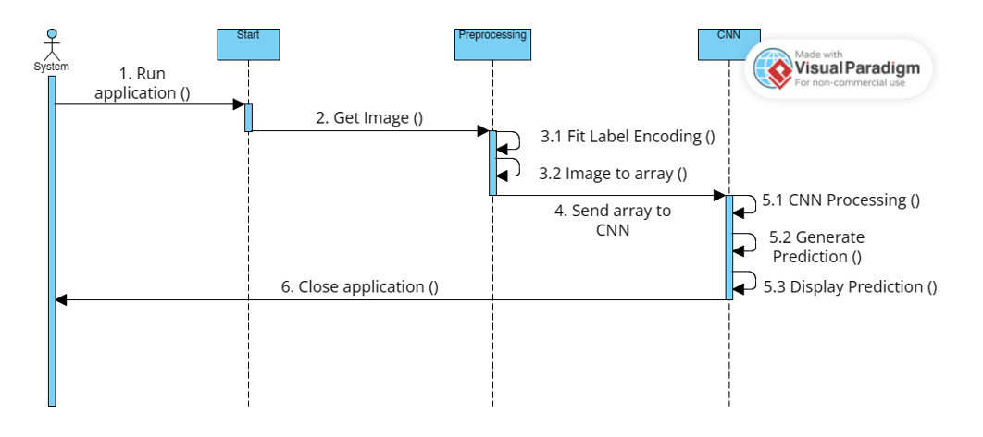

## Fig no: 1.6 Sequence diagram for Disaster Detection System

## Description:

The system begins by initiating the application, which prompts the execution sequence. Following this, it retrieves an image as its input data. Subsequently, it undergoes preprocessing steps, starting with fitting label encoding, where labels are assigned numeric values. Then, the image is converted into an array format for further processing. The array data is then forwarded to a Convolutional Neural Network (CNN) for analysis. Within the CNN module, the array undergoes processing to extract meaningful features. Based on these features, a prediction is generated by the network. Finally, the predicted outcome is displayed, providing insights derived from the image prediction. Once the processing is complete, the application gracefully concludes its operation, closing down the system.

## 4.4.4 Activity Diagram

A state chart diagram, also known as a state machine diagram, is a type of behavioural diagram in UML (Unified Modelling Language) that represents the dynamic behaviour of a system or an object over time. It shows the various states an object can be in and the transitions between these states based on events or conditions.

* **States**: States represent the different conditions or modes that an object or system can be in. Each state is depicted as a rounded rectangle and labelled with a name that describes the state.
* **Initial State**: The initial state indicates the starting point of the object or system when it is first created or enters a particular context. It is represented by a filled black circle or an arrow pointing to the initial state.
* **Final State**: The final state represents the end point of the object or system's behaviour. It is depicted as a rounded rectangle with a solid border or concentric circles.
* **Transitions**: Transitions represent the movement from one state to another in response to an event or condition. They are depicted as directed arrows with labels specifying the triggering event or condition that causes the transition. Transitions can also have optional guards or conditions that must be satisfied for the transition to occur.
* **Actions**: Actions or activities can be associated with states or transitions to specify the behaviour or operations performed when entering or exiting a state or during a transition.
* **Composite States**: Composite states allow for hierarchical organization of states, where a state can have nested substates within it. This helps in modelling complex behaviours and state hierarchies.

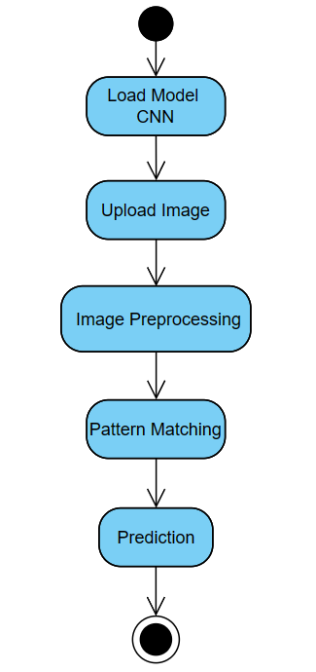

## Fig no: 1.7 Disaster Detection System Activity Diagram

## Description:

The activity diagram begins with loading the CNN model, followed by uploading an image for processing. The image undergoes preprocessing to prepare it for pattern matching. Once the preprocessing is complete, pattern matching is performed using the CNN model. Finally, a prediction is made based on the matched patterns. Overall, the diagram outlines the sequential steps involved in utilizing a CNN model to analyze and predict patterns within an uploaded image.

# 5.DESIGN

## 5.1 Design and Description of the Algorithm

The disaster detection system utilizes a Convolutional Neural Network (CNN) algorithm tailored for processing visual data, such as images, to proficiently identify and detect disaster scenarios. This algorithm follows a meticulously designed process comprising several fundamental steps. Initially, raw input images undergo preprocessing to ensure consistency and compatibility within the network. Subsequently, these preprocessed images traverse through multiple convolutional layers, where intricate features like edges, textures, and patterns are detected through convolution operations. Following each convolution operation, an activation function, typically ReLU (Rectified Linear Unit), introduces non-linearity to facilitate learning complex relationships in the data.

After convolutional processing, pooling layers are employed to reduce the spatial dimensions of the feature maps while retaining crucial information, effectively reducing computational complexity and mitigating overfitting. The resulting feature maps are then flattened into a one-dimensional array to prepare for input into the fully connected layers. In these fully connected layers, the flattened features are integrated and refined to grasp higher-level abstractions, empowering the network to comprehend relationships between different features and make accurate predictions. The output layer utilizes the softmax activation function to generate a probability distribution over the classes, ensuring that predicted probabilities sum up to one.

During the training phase, the network's performance is evaluated using a loss function, such as categorical cross-entropy, measuring the disparity between predicted and actual outputs. The Adam optimizer plays a pivotal role in minimizing the loss function and updating network parameters iteratively, adapting learning rates for optimal performance. Once trained, the network undergoes evaluation on a separate test dataset to assess its performance and generalization ability. Optionally, the network may undergo fine-tuning, adjusting hyperparameters or modifying layers to enhance performance on specific tasks or datasets. Additionally, the application has been designed using Tkinter, ensuring a user-friendly and interactive interface for seamless interaction with the disaster detection system. This meticulously designed algorithm, coupled with a user-friendly interface, empowers the disaster detection system to autonomously learn complex hierarchical representations from raw image data, facilitating accurate detection.

# 5.2 Algorithm

## 5.2.1 Disaster Detection System Algorithm: -

The Disaster Detection System Algorithm is centered around the utilization of a Convolutional Neural Network (CNN) model. This model serves as the backbone of our project, enabling efficient detection of disaster scenarios.

# Algorithm:

## STEP 1: Start

## STEP 2: Users interact with the system through a user interface to load the CNN model to the system.

**STEP 3**: Now input data, typically in the form of images depicting potential disaster scenarios.

## STEP 4: Data Processing and Preprocessing

## The Disaster Detection class receives the user-provided images and initiates the preprocessing step

## The Preprocess class undertakes preprocessing tasks, such as resizing or normalization, to prepare the images for analysis.

## STEP 5: CNN Processing

## The pre-processed images are then passed to the CNN Process class, which encapsulates the image analysis and classification functionalities.

## Within the CNN Process class, advanced CNN models are employed to analyze the images and discern potential disasters.

## STEP 6: Disaster Detection and Prediction

## The CNN models calculate the probability of detecting a disaster within the provided images and determine the type of disaster present.

## Based on the analysis, the system generates predictions regarding the presence and type of disaster detected.

## STEP 7: Output Presentation: The prediction results, including the probability of detection and the type of disaster identified, are displayed as output to the user through the user interface.

## Overall, this algorithm encapsulates the workflow of the disaster detection system, from user interaction and input to data processing, CNN analysis, prediction generation, and output presentation. By leveraging Convolutional Neural Network technology and modular design principles, the system efficiently analyzes input images to identify and classify potential disaster scenarios, providing valuable insights to users in real-time.

# 6.CODING

The goal of coding or programming phase is to translate the design of the system produced during the phase into code in a given programming language, which can be executed by a computer and the performs the computation specified by the design.

The coding phase affects both testing and maintenance. The goal of coding is not to reduce the implementation cost, but the goal should be to reduce the cost of later phase. In other words, the goal is not to simplify the job of programmer. Rather the goal should be to simplify the job of the tester and maintainer.

## 6.1 Coding Approach

There are two major approaches for coding any software system. They are top-Down approach and bottom up approach.

Bottom-up approach can suit for developing the object-oriented systems. The bottom-up coding approach is highly beneficial for machine learning projects, particularly those involving deep learning CNN models for disaster image classification. This approach involves decomposing the system into subsystems, each conducive to independent object modeling. Objects within these subsystems encapsulate functionality and operational logic. During coding, modules are developed independently, facilitating focused development and optimization. Once validated, these modules are seamlessly integrated into a cohesive system, ensuring harmonious functionality. Overall, the bottom-up approach enhances scalability, robustness, and efficiency, enabling developers to navigate the complexities of image classification with precision.

## 6.2 Programming Style

The current system adheres to coding rules for variable and method naming, ensuring traceability, understandability, modifiability, and extensibility. Developed with a focus on interactivity and user-friendliness, it features intuitively designed interfaces and clear error messaging. This commitment to programming style enhances code readability and usability, making the system robust, maintainable, and adaptable to future changes.

## 6.3 Verification and Validation

Project verification confirms model operation correctness, while validation ensures goal attainment. Rigorous coding underwent verification, evaluating design and integration. Validation techniques include form and field-level checks, guiding users to rectify errors.

**6.4 Model Code**

**Code cell 1:**

import os

from sklearn.model_selection import train_test_split

from keras.preprocessing.image import load_img, img_to_array

import numpy as np

import pandas as pd

# Set the width and height for loading images

w, h = 250, 250 # You can adjust these values based on your requirements

# List of folders with their respective label1 and label2 values

folder_data = [

{'folder': 'C:\\Users\\Asus\\OneDrive\\Desktop\\6th Sem Project\\archive\\Comprehensive Disaster Dataset(CDD)\\Fire_Disaster\\Wild_Fire', 'label1': 'Fire Disaster', 'label2': 'Wild Fire'},

{'folder': 'C:\\Users\\Asus\\OneDrive\\Desktop\\6th Sem Project\\archive\\Comprehensive Disaster Dataset(CDD)\\Land_Disaster\\Drought', 'label1': 'Land Disaster', 'label2': 'Drought'},

{'folder': 'C:\\Users\\Asus\\OneDrive\\Desktop\\6th Sem Project\\archive\\Comprehensive Disaster Dataset(CDD)\\Non_Damage\\human', 'label1': 'Human', 'label2': 'Human'},

{'folder': 'C:\\Users\\Asus\\OneDrive\\Desktop\\6th Sem Project\\archive\\Comprehensive Disaster Dataset(CDD)\\Non_Damage\\Non_Damage_Wildlife_Forest', 'label1': 'Nature', 'label2': 'Undamaged Forest'},

{'folder': "C:\\Users\\Asus\\OneDrive\\Desktop\\6th Sem Project\\archive\\Sea", 'label1': 'Sea', 'label2': 'Sea'},

{'folder': "C:\\Users\\Asus\\OneDrive\\Desktop\\6th Sem Project\\archive\\Comprehensive Disaster Dataset(CDD)\\Non_Damage\\Rain", 'label1': 'Rain', 'label2': 'Water Disaster'},

{'folder': 'C:\\Users\\Asus\\OneDrive\\Desktop\\6th Sem Project\\archive\\Comprehensive Disaster Dataset(CDD)\\Water_Disaster', 'label1': 'Water Disaster', 'label2': 'Water Disaster'}

# Add the remaining folders and label values

]

# Combine file paths and label values into a list of dictionaries

data_list = []

for folder_info in folder_data:

folder_path = folder_info['folder']

if os.path.exists(folder_path):

for root, dirs, files in os.walk(folder_path):

for file in files:

if file.endswith('.jpg') or file.endswith('.png'):

image_path = os.path.join(root, file)

data_list.append({'image_path': image_path, 'label1': folder_info['label1'], 'label2': folder_info['label2']})

else:

print(f"Folder not found: {folder_info['folder']}")

# Convert the list of dictionaries to a DataFrame

df = pd.DataFrame(data_list)

# Split data into training and testing sets with stratification

train_data, test_data = train_test_split(df, test_size=0.2, random_state=42, stratify=df['label1'])

# Load images and labels into arrays

def load_images_and_labels(data):

images = []

labels1 = []

labels2 = []

for index, row in data.iterrows():

try:

img = load_img(row['image_path'], target_size=(w, h))

img_array = img_to_array(img) / 255.0

images.append(img_array)

labels1.append(row['label1'])

labels2.append(row['label2'])

except Exception as e:

print(f"Error loading image {row['image_path']}: {e}")

return np.array(images), np.array(labels1), np.array(labels2)

# Load images and labels for training and testing sets

train_images, train_labels1, train_labels2 = load_images_and_labels(train_data)

test_images, test_labels1, test_labels2 = load_images_and_labels(test_data)

**Code Cell 2:**

import pandas as pd

# Assuming df is your DataFrame

# df['label'] is the column for which you want to get the value counts

value_counts = df['label1'].value_counts()

print(value_counts)

**Output Cell 2:**

label1

Nature 4900

Water Disaster 626

Fire Disaster 361

Human 297

Rain 207

Land Disaster 201

Sea 90

Name: count, dtype: int64

**Code Cell 3:**

import numpy as np

import matplotlib.pyplot as plt

from keras.models import Sequential

from keras.layers import Conv2D, MaxPooling2D, Flatten, Dense, Dropout

from keras.callbacks import EarlyStopping, ModelCheckpoint

from keras.datasets import mnist

import keras

from sklearn.model_selection import train_test_split

from sklearn.preprocessing import LabelEncoder

import pandas as pd

from PIL import Image

import os

**Code Cell 4:**

from sklearn.preprocessing import LabelEncoder

from keras.utils import to_categorical

# Determine the number of unique classes for label1 and label2

num_classes1 = len(df['label1'].unique())

num_classes2 = len(df['label2'].unique())

# Create a LabelEncoder for each category

label_encoder1 = LabelEncoder()

label_encoder2 = LabelEncoder()

# Fit the LabelEncoder on the combined set of training and test labels

combined_labels1 = np.concatenate([train_labels1, test_labels1])

combined_labels2 = np.concatenate([train_labels2, test_labels2])

label_encoder1.fit(combined_labels1)

label_encoder2.fit(combined_labels2)

# Transform string labels to numerical indices

train_labels1_indices = label_encoder1.transform(train_labels1)

train_labels2_indices = label_encoder2.transform(train_labels2)

test_labels1_indices = label_encoder1.transform(test_labels1)

test_labels2_indices = label_encoder2.transform(test_labels2)

# Apply to_categorical on numerical indices

train_labels1_one_hot = to_categorical(train_labels1_indices, num_classes=num_classes1)

train_labels2_one_hot = to_categorical(train_labels2_indices, num_classes=num_classes2)

test_labels1_one_hot = to_categorical(test_labels1_indices, num_classes=num_classes1)

test_labels2_one_hot = to_categorical(test_labels2_indices, num_classes=num_classes2)

**Code Cell 5:**

from keras.models import Model

from keras.layers import Input, Conv2D, MaxPooling2D, Flatten, Dense, concatenate

# Define input shape

input_shape = (250, 250, 3) # Adjust based on your image size and channels

# Define the input layer

input_layer = Input(shape=input_shape, name='input_layer')

# Convolutional block

conv1 = Conv2D(32, (3, 3), activation='relu', padding='same')(input_layer)

pool1 = MaxPooling2D((2, 2))(conv1)

conv2 = Conv2D(64, (3, 3), activation='relu', padding='same')(pool1)

pool2 = MaxPooling2D((2, 2))(conv2)

flatten = Flatten()(pool2)

# First output branch for label1

dense1 = Dense(128, activation='relu')(flatten)

output1 = Dense(7, activation='softmax', name='output1')(dense1)

# Combine both output branches

model = Model(inputs=input_layer, outputs=[output1])

# Compile the model

model.compile(optimizer='adam', loss='categorical_crossentropy', metrics=['accuracy'])

**Code Cell 6:**

from keras.models import Model

# Create model1 with output1 branch

model1 = Model(inputs=model.input, outputs=model.get_layer('output1').output)

model1.compile(optimizer='adam', loss='categorical_crossentropy', metrics=['accuracy'])

**Code Cell 7:**

# Define callbacks

es1 = EarlyStopping(monitor='val_accuracy', min_delta=0.01, patience=2, verbose=1, restore_best_weights=True)

mc1 = ModelCheckpoint("Finally_Final.keras", monitor="val_accuracy", verbose=1, save_best_only=True)

**Code Cell 8:**

# Fit method for training model1

#model1.fit(

# x=train_images,

# y=train_labels1_one_hot,

# epochs=10,

#validation_data=(test_images, test_labels1_one_hot)

#)

**Code Cell 9:**

# Fit method for training model2

model1.fit(

x=train_images,

y=train_labels1_one_hot,

epochs=3,

validation_data=(test_images, test_labels1_one_hot),

callbacks=[es1, mc1]

)

**Output Cell 9:**

164/164 [==============================] - ETA: 0s - loss: 0.7262 - accuracy: 0.8385

Epoch 1: val_accuracy improved from -inf to 0.91985, saving model to Finally_Final.keras

164/164 [==============================] - 108s 644ms/step - loss: 0.7262 - accuracy: 0.8385 - val_loss: 0.2729 - val_accuracy: 0.9198

Epoch 2/3

164/164 [==============================] - ETA: 0s - loss: 0.1913 - accuracy: 0.9395

Epoch 2: val_accuracy improved from 0.91985 to 0.93588, saving model to Finally_Final.keras

164/164 [==============================] - 90s 551ms/step - loss: 0.1913 - accuracy: 0.9395 - val_loss: 0.1945 - val_accuracy: 0.9359

Epoch 3/3

164/164 [==============================] - ETA: 0s - loss: 0.0816 - accuracy: 0.9761

Epoch 3: val_accuracy improved from 0.93588 to 0.94885, saving model to Finally_Final.keras

164/164 [==============================] - 89s 541ms/step - loss: 0.0816 - accuracy: 0.9761 - val_loss: 0.1898 - val_accuracy: 0.9489

<keras.src.callbacks.History at 0x1f8ecdd9010>

**Code Cell 10:**

# Evaluate model1

loss1, accuracy1 = model1.evaluate(test_images, test_labels1_one_hot, verbose=1)

print(f"Model1 Accuracy: {accuracy1 * 100:.2f}%")

**Output Cell 10:**

41/41 [==============================] - 4s 95ms/step - loss: 0.1898 - accuracy: 0.9489

Model1 Accuracy: 94.89%

**6.5 Application Code**

import tkinter as tk

from tkinter import filedialog, messagebox, ttk

from PIL import Image, ImageTk

from keras.models import load_model

import os

from keras.preprocessing.image import load_img, img_to_array

from sklearn.preprocessing import LabelEncoder

import numpy as np

from keras.layers import Conv2D, MaxPooling2D

from keras.models import Model

import tkinter as tk

from tkinter import ttk

import threading

import time

class HomeScreen:

def __init__(self, root):

self.root = root

self.root.title("Home Screen")

self.root.state('zoomed')

self.current_screen = None

self.intro_screen = None

self.show_intro_screen()

def show_intro_screen(self):

self.current_screen = self.intro_screen = tk.Frame(self.root)

self.intro_screen.pack(fill="both", expand=True)

image_path = "C:\\Users\\Asus\\OneDrive\\Desktop\\6th Sem Project\\Final Dependencies\\Home.jpg"

image = Image.open(image_path)

image = image.resize((1500, 820))

image = ImageTk.PhotoImage(image)

image_label = tk.Label(self.intro_screen, image=image)

image_label.image = image

image_label.place(x=0, y=0, relwidth=1, relheight=1)

button_frame = tk.Frame(self.intro_screen, bg="#1f497d")

button_frame.place(relx=0.73, rely=0.85, anchor=tk.CENTER)

button2 = tk.Button(button_frame, text="Abstract", command=self.run_abstract_screen, width=15, height=3, bg="#e3fef7")

button3 = tk.Button(button_frame, text="Help", command=self.run_help_screen, width=15, height=3, bg="#e3fef7")

button4 = tk.Button(button_frame, text="Start", command=self.run_model_screen, width=15, height=3, bg="#e3fef7")

button2.grid(row=0, column=0, padx=(20, 20))

button3.grid(row=0, column=1, padx=(20, 20))

button4.grid(row=0, column=2, padx=(20, 20))

def run_abstract_screen(self):

self.current_screen.destroy()

self.current_screen = tk.Toplevel(self.root)

self.current_screen.title("Abstract Screen")

self.current_screen.state('zoomed')

abstract_image_path = "C:\\Users\\Asus\\OneDrive\\Desktop\\6th Sem Project\\Final Dependencies\\Abstract.jpg"

abstract_image = Image.open(abstract_image_path)

abstract_image = abstract_image.resize((1500, 820))

abstract_image = ImageTk.PhotoImage(abstract_image)

abstract_image_label = tk.Label(self.current_screen, image=abstract_image)

abstract_image_label.image = abstract_image

abstract_image_label.place(x=0, y=0, relwidth=1, relheight=1)

home_button = tk.Button(

self.current_screen,

text="Home",

command=self.back_to_home,

width=10,

height=2,

bg="#e3fef7"

)

home_button.place(relx=0.02, rely=0.02)

def run_help_screen(self):

self.current_screen.destroy()

self.current_screen = tk.Toplevel(self.root)

self.current_screen.title("Help Screen")

self.current_screen.state('zoomed')

help_image_path = "C:\\Users\\Asus\\OneDrive\\Desktop\\6th Sem Project\\Final Dependencies\\Help.jpg"

help_image = Image.open(help_image_path)

help_image = help_image.resize((1500, 820))

help_image = ImageTk.PhotoImage(help_image)

help_image_label = tk.Label(self.current_screen, image=help_image)

help_image_label.image = help_image

help_image_label.place(x=0, y=0, relwidth=1, relheight=1)

home_button = tk.Button(

self.current_screen,

text="Home",

command=self.back_to_home,

width=10,

height=2,

bg="#e3fef7"

)

home_button.place(relx=0.02, rely=0.02)

def run_model_screen(self):

self.current_screen.destroy()

ModelGUI(self.root)

def back_to_home(self):

self.current_screen.destroy()

self.show_intro_screen()

class ModelGUI:

def __init__(self, root):

self.root = root

self.root.title("Load Keras Model")

self.root.state('zoomed')

self.root.configure(bg='#1f497d') # Set background color of root window

# Add a label for the welcome message

self.welcome_label = tk.Label(self.root, text="Welcome To The Disaster Detection System", font=("Times New Roman", 25), bg='#1f497d', fg='white')

self.welcome_label.pack(pady=(20, 10)) # Adjusted pady here

# Frame to hold back and next buttons

self.navigation_frame = tk.Frame(self.root, bg='#1f497d') # Set background color of frame

self.navigation_frame.pack(pady=10)

self.back_button = tk.Button(self.navigation_frame, text="Back", command=self.back_to_home_screen, font=("Arial", 14), height=3, width=20, bg='#e3fef7', fg='black')

self.back_button.pack(side=tk.LEFT, padx=10)

self.next_button = tk.Button(self.navigation_frame, text="Next", command=self.open_select_image_screen, font=("Arial", 14), height=3, width=20, bg='#e3fef7', fg='black')

self.next_button.pack(side=tk.LEFT, padx=10)

self.load_model_button = tk.Button(self.root, text="Load Model", command=self.load_model, font=("Arial", 14), height=3, width=20, bg='#e3fef7', fg='black')

self.load_model_button.pack(pady=10)

# Frame for model summary

self.model_summary_frame = tk.Frame(self.root, bg='#1f497d')

self.model_summary_frame.pack(expand=False, fill='both', padx=20, pady=(0, 2)) # Adjusted pady here

# Frame for the default screen color

self.default_screen_frame = tk.Frame(self.root, bg='#1f497d')

self.default_screen_frame.pack(expand=True, fill='both')

# Create model summary inside self.model_summary_frame

self.summary_frame = ttk.Frame(self.model_summary_frame, style="Custom.TFrame")

self.summary_frame.pack(expand=False, fill='both', padx=5, pady=3)

self.loaded_model = None # Attribute to store the loaded model

def load_model(self):

try:

model_path = filedialog.askopenfilename(title="Select Model", filetypes=[("Keras Model", "*.keras")])

with open('C:\\Users\\Asus\\OneDrive\\Desktop\\6th Sem Project\\Finally Final\\modelpath.txt', 'w') as model_file:

model_file.write(model_path) # Write the model path to the modelpath.txt file

self.loaded_model = load_model(model_path)

self.show_model_summary(self.loaded_model)

messagebox.showinfo("Model Loaded", "Model loaded successfully!")

# Configure the background color of any additional space

self.root.configure(bg='#1f497d')

except Exception as e:

messagebox.showerror("Error", f"Error loading model: {e}")

def show_model_summary(self, model):

for widget in self.summary_frame.winfo_children():

widget.destroy()

tree = ttk.Treeview(self.summary_frame, style="Custom.Treeview")

tree.pack(expand=True, fill='both')

tree["columns"] = ("Layer", "Output Shape")

tree.column("#0", width=0, stretch=tk.NO)

tree.heading("#1", text="Layer")

tree.heading("#2", text="Output Shape")

for i, layer in enumerate(model.layers):

output_shape = layer.output_shape[1:] if layer.output_shape else "-"

tree.insert("", "end", text=f"Layer {i}", values=(layer.name, output_shape))

for col in tree["columns"]:

tree.column(col, width=150, stretch=tk.YES)

def back_to_home_screen(self):

self.root.destroy()

root = tk.Tk()

app = HomeScreen(root)

root.mainloop()

def open_select_image_screen(self):

self.root.destroy()

root = tk.Tk()

app = ImagePreviewApp(root)

root.mainloop()

class LoadingScreen:

def __init__(self):

self.window = tk.Tk()

self.window.title("Loading")

self.window.state('zoomed') # Maximize window

self.window.configure(bg='#1f497d') # Set background color to #1f497d

self.label = ttk.Label(self.window, text="Loading, please wait...", font=("Arial", 45), foreground='white', background='#1f497d') # White text color

self.label.pack(pady=5)

def start(self):

self.thread = threading.Thread(target=self._update_progress)

self.thread.start()

self.window.mainloop()

def _update_progress(self):

time.sleep(8) # Wait for 5 seconds

self.label.config(text="Loading completed") # Update the label to indicate task completion

self.window.after(2000, self.window.destroy) # Destroy the window after 2 seconds

class ImagePreviewApp:

def __init__(self, root):

self.root = root

self.root.title("Image Preview")

self.root.state('zoomed')

self.root.configure(bg='#1f497d') # Set background color of root window

# Add a label for the welcome message

self.welcome_label = tk.Label(self.root, text="Welcome To The Disaster Detection System", font=("Times New Roman", 25), bg='#1f497d', fg='white')

self.welcome_label.pack(pady=(20, 10)) # Adjusted pady here

# Frame for buttons

self.button_frame = tk.Frame(self.root, bg='#1f497d')

self.button_frame.pack(side=tk.TOP, pady=10)

# Back button

self.back_button = tk.Button(self.button_frame, text="Back", command=self.back_to_model_from_image, font=("Arial", 16), width=15, height=2, bg='#e3fef7', fg='#1f497d')

self.back_button.pack(side=tk.LEFT, padx=20)

# Next button

self.next_button = tk.Button(self.button_frame, text="Next", command=self.imagetoprocess, font=("Arial", 16), width=15, height=2, bg='#e3fef7', fg='#1f497d')

self.next_button.pack(side=tk.LEFT, padx=20)

# Select image button

self.select_button = tk.Button(self.root, text="Upload Image", command=self.select_image, font=("Arial", 16), bg='#e3fef7', fg='#1f497d')

self.select_button.pack(pady=20)

# Image and details labels

self.image_label = tk.Label(self.root, bg='#1f497d')

self.image_label.pack(pady=10)

self.details_label = tk.Label(self.root, justify='left', bg='#1f497d', fg='white', font=("Arial", 14)) # Increased font size

self.details_label.pack(pady=10)

def select_image(self):

file_path = filedialog.askopenfilename(

title="Upload Image",

filetypes=[("Image files", "*.png;*.jpg;*.jpeg;*.gif;*.bmp")]

)

if file_path:

if self.is_image_compatible(file_path):

# Write the image path to the imagepath.txt file

with open('C:\\Users\\Asus\\OneDrive\\Desktop\\6th Sem Project\\Finally Final\\imagepath.txt', 'w') as path_file:

path_file.write(file_path)

self.display_image_preview(file_path)

self.display_image_details(file_path)

else:

messagebox.showwarning("Incompatible Image", "The selected image must have dimensions of at least 150x150 pixels.")

def is_image_compatible(self, file_path):

img = Image.open(file_path)

width, height = img.size

return width >= 150 and height >= 150

def display_image_preview(self, file_path):

img = Image.open(file_path)

img = img.resize((450, 450))

photo = ImageTk.PhotoImage(img)

self.image_label.config(image=photo)

self.image_label.image = photo

def display_image_details(self, file_path):

file_name = os.path.basename(file_path)

file_type = os.path.splitext(file_path)[1]

img = Image.open(file_path)

width, height = img.size

details_text = f"File Name: {file_name}\nFile Path: {file_path}\nFile Type: {file_type}\nDimensions: {width} x {height}"

self.details_label.config(text=details_text)

def imagetoprocess(self):

# Create an Event to signal when the ImageProcessingApp is ready

self.app_ready_event = threading.Event()

# Start the loading screen in a separate thread

loading_thread = threading.Thread(target=self._start_loading_screen)

loading_thread.start()

# Start the ImageProcessingApp in the main thread

self._create_image_processing_app()

def _start_loading_screen(self):

# Start the loading screen

loading_screen = LoadingScreen()

loading_screen.start()

def _create_image_processing_app(self):

# Create the ImageProcessingApp

self.root.destroy() # Assuming self.root is initialized elsewhere

root = tk.Tk()

app = ImageProcessingApp(root)

# Set the flag to signal that the ImageProcessingApp is ready

self.app_ready_event.set()

root.mainloop()

def back_to_model_from_image(self):

self.root.destroy()

root = tk.Tk()

app = ModelGUI(root)

root.mainloop()

class ImageProcessingApp:

def __init__(self, root):

self.root = root

self.root.title("Image Processing App")

self.root.state('zoomed') # Maximize the window

self.original_image = None

self.processed_image = None

# Create a frame for the buttons

self.button_frame = tk.Frame(self.root)

self.button_frame.pack(side=tk.TOP, fill=tk.X, pady=10)

# Back button

self.back_button = tk.Button(self.button_frame, text="Back", command=self.run_back_script, width=10)

self.back_button.pack(side=tk.LEFT, padx=(10, 5))

# Next button

self.next_button = tk.Button(self.button_frame, text="Next", command=self.run_next_script, width=10)

self.next_button.pack(side=tk.LEFT, padx=5)

# Process button

self.process_button = tk.Button(self.button_frame, text="Process Image", command=self.visualize_feature_maps, width=15)

self.process_button.pack(side=tk.LEFT, padx=5)

# Canvas and scrollbar

self.canvas = tk.Canvas(self.root)

self.canvas.pack(side=tk.LEFT, fill=tk.BOTH, expand=True)

self.frame = tk.Frame(self.canvas)

self.frame.bind("<Configure>", self.on_frame_configure)

self.scrollbar = tk.Scrollbar(self.root, orient="vertical", command=self.canvas.yview)

self.scrollbar.pack(side=tk.RIGHT, fill="y")

self.canvas.configure(yscrollcommand=self.scrollbar.set)

self.canvas.create_window((0, 0), window=self.frame, anchor="nw")

self.process_steps = []

self.current_step = 0

# Initialize model attribute

self.model = None

# Automatically load the image and model

self.load_model_and_image()

def load_model_and_image(self):

try:

with open('C:\\Users\\Asus\\OneDrive\\Desktop\\6th Sem Project\\Finally Final\\imagepath.txt', 'r') as f:

image_path = f.read().strip()

if image_path:

self.original_image = Image.open(image_path)

# Resize the image to 700x700 pixels

resized_image = self.original_image.resize((700, 700))

self.display_image(resized_image)

else:

messagebox.showwarning("Image Not Found", "Please specify the image path.")

except FileNotFoundError:

messagebox.showwarning("Image Not Found", "Please specify the image path.")

try:

with open('C:\\Users\\Asus\\OneDrive\\Desktop\\6th Sem Project\\Finally Final\\modelpath.txt', 'r') as f:

model_path = f.read().strip()

if model_path:

self.model = load_model(model_path)

self.process_button.config(state=tk.NORMAL)

else:

messagebox.showwarning("Model Not Found", "Please specify the model path.")

except FileNotFoundError:

messagebox.showwarning("Model Not Found", "Please specify the model path.")

def visualize_feature_maps(self):

if self.original_image is not None and self.model is not None:

self.process_button.config(state=tk.DISABLED)

self._visualize_feature_maps()

else:

messagebox.showwarning("Image or Model not found", "Please make sure both image and model are loaded.")

def _visualize_feature_maps(self):

# Resize the image to match the required input size of the CNN model

resized_image = self.original_image.resize((250, 250))

self.display_image(resized_image, "Resized Image")

# Get the convolutional and max pooling layers

conv_pool_layers = [layer for layer in self.model.layers if isinstance(layer, (Conv2D, MaxPooling2D))]

# Create a feature map model

feature_map_model = Model(inputs=self.model.inputs, outputs=[layer.output for layer in conv_pool_layers])

# Convert the image to an array

img_array = img_to_array(resized_image)

img_array = np.expand_dims(img_array, axis=0)

# Get the feature maps for the image

feature_maps = feature_map_model.predict(img_array)

print("Number of feature maps:", len(feature_maps))

# Plot feature maps of convolutional and max pooling layers

for layer, feature_map in zip(conv_pool_layers, feature_maps):

print("Layer:", layer.name)

print("Feature map shape:", feature_map.shape)

self._plot_feature_maps(layer.name, feature_map)

def _plot_feature_maps(self, layer_name, feature_map):

num_features = feature_map.shape[-1]

size = feature_map.shape[1]

images_per_row = 4 # Set the number of images to display per row

row_count = 0

# Create a frame to contain the row of images

row_frame = tk.Frame(self.frame)

row_frame.pack()

for i in range(num_features):

feature_image = feature_map[0, :, :, i]

feature_image_mean = feature_image.mean()

feature_image_std = feature_image.std()

if feature_image_std != 0: # Avoid division by zero

feature_image -= feature_image_mean

feature_image /= feature_image_std

else:

feature_image -= feature_image_mean

feature_image *= 64

feature_image += 128

feature_image = np.clip(feature_image, 0, 255).astype('uint8')

image = Image.fromarray(feature_image)

# Display image in the row frame

label = tk.Label(row_frame, text=f"{layer_name}_{i}")

label.pack(side='left')

photo = ImageTk.PhotoImage(image)

label = tk.Label(row_frame, image=photo)

label.image = photo

label.pack(side='left') # Display images side by side

row_count += 1

# If the number of images in the row equals images_per_row or if this is the last image

if row_count == images_per_row or i == num_features - 1:

row_count = 0 # Reset row count

# Create a new row frame

row_frame = tk.Frame(self.frame)

row_frame.pack()

def _add_new_line(self):

label = tk.Label(self.frame, text="") # Empty label to add new line

label.pack()

def display_image_in_frame(self, image, layer_name):

label = tk.Label(self.frame, text=layer_name)

label.pack()

photo = ImageTk.PhotoImage(image)

label = tk.Label(self.frame, image=photo)

label.image = photo

label.pack(side='left') # Display images side by side

def display_image(self, image, layer_name=None):

# Clear existing images from the frame

for widget in self.frame.winfo_children():

widget.destroy()

# Display the new image

image = ImageTk.PhotoImage(image)

self.image_label = tk.Label(self.frame, image=image)

self.image_label.image = image

self.image_label.pack(side='top', fill='both', expand=True) # Center the image horizontally

# Display the layer name if provided

if layer_name:

label = tk.Label(self.frame, text=layer_name)

label.pack()

def on_frame_configure(self, event):

self.canvas.configure(scrollregion=self.canvas.bbox("all"))

def run_back_script(self):

# Create the ImageProcessingApp

self.root.destroy() # Assuming self.root is initialized elsewhere

root = tk.Tk()

app = ImagePreviewApp(root)

def run_next_script(self):

# Create an Event to signal when the ImageProcessingApp is ready

self.app_ready_event = threading.Event()

# Start the loading screen in a separate thread

loading_thread = threading.Thread(target=self._start_loading_screen)

loading_thread.start()

# Start the ImageProcessingApp in the main thread

self.resultscreen()

def _start_loading_screen(self):

# Start the loading screen

loading_screen = LoadingScreen()

loading_screen.start()

def resultscreen(self):

# Create the ImageProcessingApp

self.root.destroy() # Assuming self.root is initialized elsewhere

root = tk.Tk()

app = ResultScreen(root)

# Set the flag to signal that the ImageProcessingApp is ready

self.app_ready_event.set()

root.mainloop()

class ResultScreen:

def __init__(self, root):

self.root = root

self.root.title("Disaster Classifier")

self.root.configure(bg="#1f497d")

self.root.state('zoomed')

frame = tk.Frame(self.root, bg="#1f497d")

frame.pack(pady=10)

self.image_label = tk.Label(frame, bg="#1f497d")

self.image_label.grid(row=0, column=0, padx=20, pady=10)

self.result_label = tk.Label(frame, text="", font=("Helvetica", 16), bg="#1f497d")

self.result_label.grid(row=0, column=1, padx=20, pady=10)

button_frame = tk.Frame(self.root, bg="#1f497d")

button_frame.pack(side=tk.BOTTOM, pady=(50, 10))

back_button = tk.Button(button_frame, text="Back", command=self.run_back_script, bg="#e3fef7", fg="#1f497d", width=25, height=3)

back_button.grid(row=0, column=0, padx=(10, 5))

home_button = tk.Button(button_frame, text="Home", command=self.run_home_script, bg="#e3fef7", fg="#1f497d", width=25, height=3)

home_button.grid(row=0, column=1, padx=(5, 10))

self.load_and_process_image()

@staticmethod

def preprocess_image_for_app(file_path):

try:

img = load_img(file_path, target_size=(250, 250))

img_array = img_to_array(img) / 255.0

return img_array

except Exception as e:

print(f"Error preprocessing image: {e}")

return None

def load_and_process_image(self):

with open('C:\\Users\\Asus\\OneDrive\\Desktop\\6th Sem Project\\Finally Final\\modelpath.txt', 'r') as f:

model_path = f.read().strip()

with open('C:\\Users\\Asus\\OneDrive\\Desktop\\6th Sem Project\\Finally Final\\imagepath.txt', 'r') as f:

image_path = f.read().strip()

self.classify_and_display_result(image_path, model_path)

def classify_and_display_result(self, image_path, model_path):

model = load_model(model_path)

target_labels = ['Fire Disaster', 'Land Disaster', 'Human', 'Nature', 'Sea', 'Rain', 'Water Disaster']

label_encoder = LabelEncoder()

label_encoder.fit(target_labels)

image_array = self.preprocess_image_for_app(image_path)

if image_array is not None:

predictions = model.predict(np.expand_dims(image_array, axis=0))

class_index = np.argmax(predictions[0])

class_label = label_encoder.inverse_transform([class_index])[0]

if class_label in ['Human', 'Nature', 'Sea', 'Rain']:

result_text = f"Disaster Not Detected\n\n{class_label}\n"

else:

result_text = f"Disaster Type Prediction:\n\n{class_label}"

self.result_label.config(text=result_text, fg="white")

img = Image.open(image_path)

img = img.resize((650, 650))

img = ImageTk.PhotoImage(img)

self.image_label.config(image=img)

self.image_label.image = img

def run_back_script(self):

# Create an Event to signal when the ImageProcessingApp is ready

self.app_ready_event = threading.Event()

# Start the loading screen in a separate thread

loading_thread = threading.Thread(target=self.load1)

loading_thread.start()

# Start the ImageProcessingApp in the main thread

self.pscreen()

def load1(self):

# Start the loading screen

loading_screen = LoadingScreen()

loading_screen.start()

def pscreen(self):

# Create the ImageProcessingApp

self.root.destroy() # Assuming self.root is initialized elsewhere

root = tk.Tk()

app = ImageProcessingApp(root)

# Set the flag to signal that the ImageProcessingApp is ready

self.app_ready_event.set()

root.mainloop()

def run_home_script(self):

self.root.destroy() # Close the current screen

root = tk.Tk() # Create a new Tkinter window

app = HomeScreen(root) # Open the home screen

root.mainloop()

def main():

root = tk.Tk()

app = HomeScreen(root)

root.mainloop()

if __name__ == "__main__":

main()

# 7.TESTING

Testing is the process of finding differences between the expected behavior specified by system models and the observed behavior of the system. Testing is a critical role in quality assurance and ensuring the reliability of development and these errors will be reflected in the codes the application should be thoroughly tested and validated. Unit testing in a machine learning project involves scrutinizing the consistency between the model's design and its individual components, such as layers, activation functions, and loss functions. Structural testing aims to uncover discrepancies between the overall architecture of the model, including its layers and connections, and a subset of integrated components, such as feature extraction layers or classification layers. Functional testing focuses on verifying the alignment between the model's intended use cases, such as image classification or sentiment analysis, and its actual behavior. Performance testing assesses how well the model meets non-functional requirements, such as inference speed or memory consumption, compared to specified benchmarks. From a modeling perspective, testing entails systematically evaluating the model against its expected behavior and performance metrics, aiming to identify any deviations or shortcomings. The ultimate goal of testing in the project is to design tests that effectively challenge the model's assumptions and capabilities, exposing any flaws or limitations in its implementation.

## 7.1. Testing Activities

Testing a large system is a complex system is a complex activity and like any complex activity. It must be breaking into smaller activities. Thus, incremental testing was performed on the project i.e., components and subsystems of the system were tested separately before integrating them to from the subsystem for system testing.

## 7.2. Unit Testing

Unit testing focuses on the building blocks of the software system that is the objects and subsystem. There are three motivations behind focusing on components. First unit testing reduces the complexity of overall test activities allowing focus on smaller units of the system, second unit testing makes it easier to pinpoint and correct faults given that few components are involved in the rest. Third unit testing allows parallelism in the testing activities, that is each component are involved in the test. Third unit testing allows parallelism in the testing activities that is each component can be tested independently of one another.Unit testing targets the fundamental building blocks of the system, namely the neural network layers and components. Three primary motivations drive the emphasis on these components. Firstly, unit testing reduces the complexity of overall testing efforts by focusing on smaller units of the model, facilitating more targeted and manageable testing. Secondly, it enhances fault identification and correction as only a few components are involved in each test, making it easier to pinpoint and rectify any issues. Lastly, unit testing enables parallelism in testing activities, allowing each neural network component to be tested independently, thereby improving efficiency and scalability in the testing process.

## 7.2.1 Integration Testing

Integrated testing is pivotal for identifying undetected defects by incrementally combining and testing small groups of components, beginning from individual layers and progressing to more complex parts of the model. Adhering to a top-down testing strategy, each layer's components are unit tested first, followed by integration testing of subsequent layers until the entire CNN model is assembled and thoroughly validated. For instance, individual testing ensures the functionality of each layer, while integration testing verifies their compatibility and performance when combined. This iterative approach guarantees the robustness and accuracy of the CNN model, culminating in a comprehensive assessment of its functionality and performance.

**7.2.2 Validation Testing:**

Once the app is fully assembled, interfacing issues are addressed, and a final series of software tests, known as validation testing, is conducted. Validation testing ensures that the system functions in a manner reasonably expected by the end user.

**7.3 System Testing**

### System testing for the project involves a comprehensive evaluation of the integrated system, including the CNN model and its interfacing with the Tkinter GUI application. This testing phase aims to verify that the entire system functions as intended and meets the specified requirements. Adopting a black-box testing approach, system testing does not require knowledge of the internal workings of the code or logic. Usability testing assesses the user-friendliness of the application, ensuring that users with minimal knowledge of image classification and CNN can navigate and utilize the features effectively. Performance testing evaluates the system's ability to handle various tasks efficiently, including image processing and classification, even under high-demand scenarios. Installation testing ensures seamless deployment and setup of the CNN project in the target environment. Ultimately, system testing validates the system's capability to accurately perform tasks such as image classification and provide reliable results to users.

### 7.3.1 Usability testing:

It is technique used to evaluate a product by testing it on users. It finds differences between the functional requirements and the system. With minimum knowledge of machine learning is enough for to use our project.

### 7.3.2 Performance testing:

It covers a broad range of engineering or functional evaluations to meet measurable performance characteristics. The coding of the system involves a simple but effective method that can perform well even the user submits text with high security.

### 7.3.3 Installation testing

It is a kind of quality assurance work in the software industry that focuses on what customers will need to do to install and set up the new software successfully. The system is installed in the target environment.

Finally, we test whether the application is able to accurately classify the images. This involves testing all the individual system of the application. This is achieved through System testing.

## 7.4 Testing Types

### Unit testing:

It finds the differences between the object design model and its corresponding components. In this test each component is tested independent of the other thus allowing parallelism in testing activity.

Ex: Testing the model loading process and uploading image. If one the processes is not performed the result won’t be displayed

### Structural testing:

It finds difference between the system design model and a subset of integrated sub-

systems.

### Functional testing:

It finds differences between the use case model and the system.

### Performance testing:

It finds difference between non-functional requirements and actual system performance.

## 7.5 Testing Plain

Testing accounts for 45-75% of the typical project effort. It is also one of the most commonly underestimated activities on a project. A test plan is a document that answers the basic questions about your testing effort. It needs to be initiated during the requirements gathering phase of your project and should evolve into a roadmap for the testing phase.

Test Planning enables a more reliable estimate of the testing effort up front. It allows the project team to consider ways to reduce the testing effort without being under time pressure. Test Plan helps to identify problem areas and focuses the testing team’s attention on the critical paths. Test plan reduces the probability of implementing non-tested components.

**7.6. Test Case Report**

**7.6.1 Test Case 1: Initializing App**

**Test Case Id:** 01

**Test Case Name:** Initializing app

**Test Case Name:** Initialization.

**Table 7.6.1: Test Case-1: Initialization App**

|  |  |  |  |
| --- | --- | --- | --- |
| **Description** | **Expected Value** | **Observed Value** | **Result** |
| The application is started. | The GUI should be visible as intended. | The GUI is visible | The GUI is working. |
| Loading the model. | The model should be loaded and the model summary must be displayed. | The model loaded successfully and the summary is visible | Model Summary |

**7.6.2 Test Case 2: Processing and Prediction**

## Test Case Id: 02

**Test Case Name:** Processing CNN

**Test Case Type:** Visualization and Prediction

**Table 7.6.2: Test Case-2: Processing and Prediction**

|  |  |  |  |
| --- | --- | --- | --- |
| **Description** | **Expected Value** | **Observed Value** | **Result** |
| User uploads the image and processes it | The image processed through the CNN and Feature maps must be visible. | Feature Maps are displayed. | Feature Maps. |
| User clicks next and prediction must be displayed. | Prediction. | The result class of the prediction. | Class prediction. |

# 8.RESULTS

# 

# Fig 8.1 Home Screen

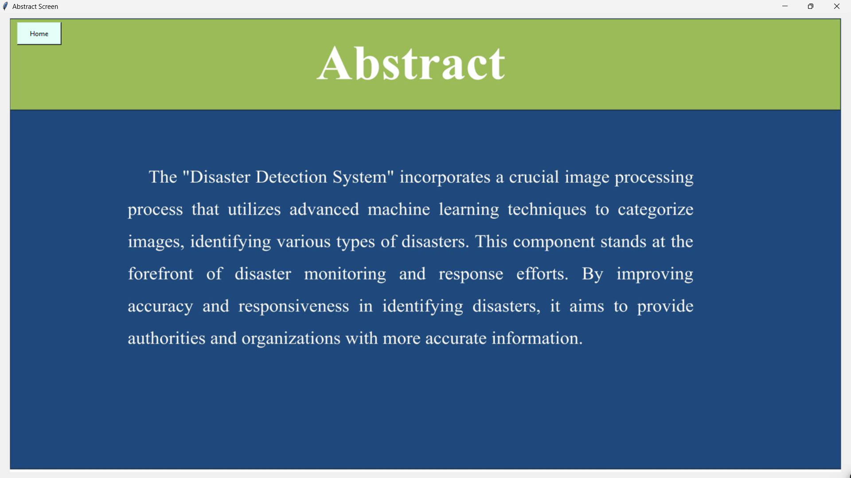

# Fig 8.2 Abstract Screen

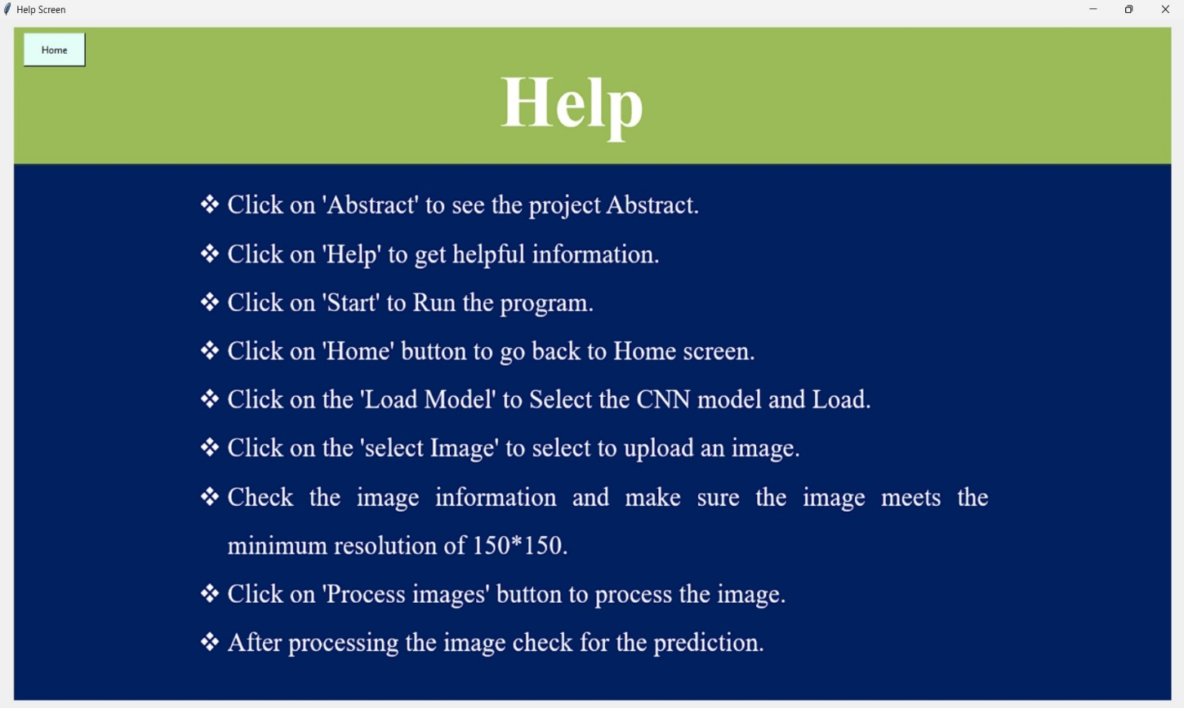

**Fig 8.3 Help Screen**

# 

# 

**Fig 8.4 Load Model Screen**

# 

**Fig 8.4 Load Model Selecting Screen**

# 

**Fig 8.4 Model Loaded Successfully Screen**

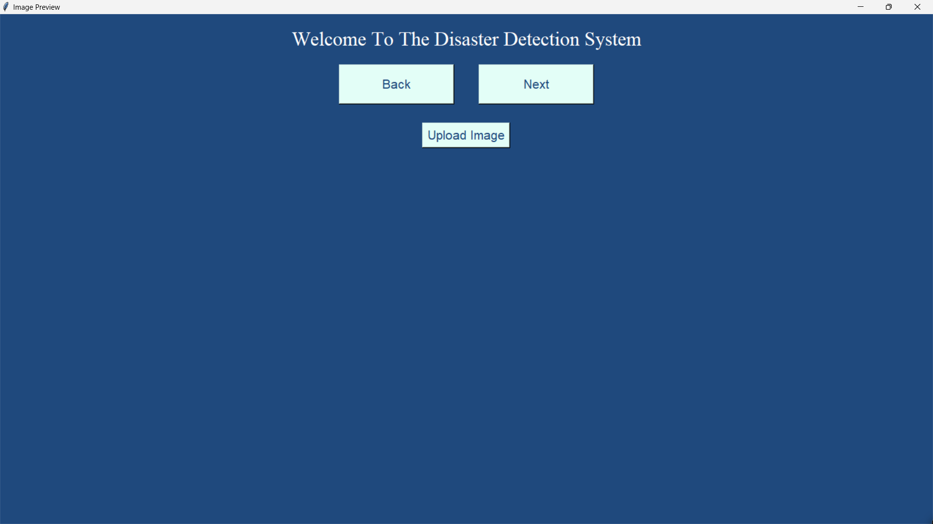

**Fig 8.5 Upload Image Screen**

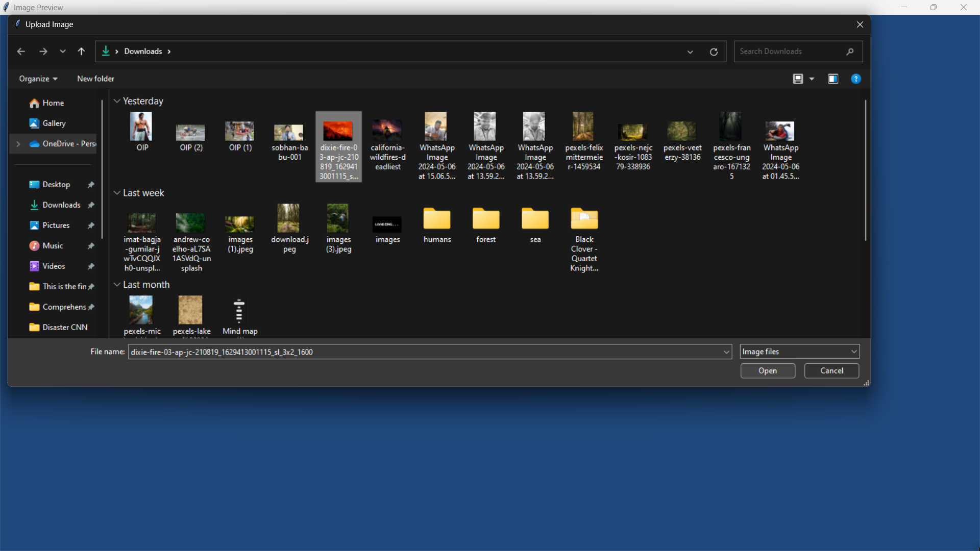

**Fig 8.5 Selecting Image Screen**

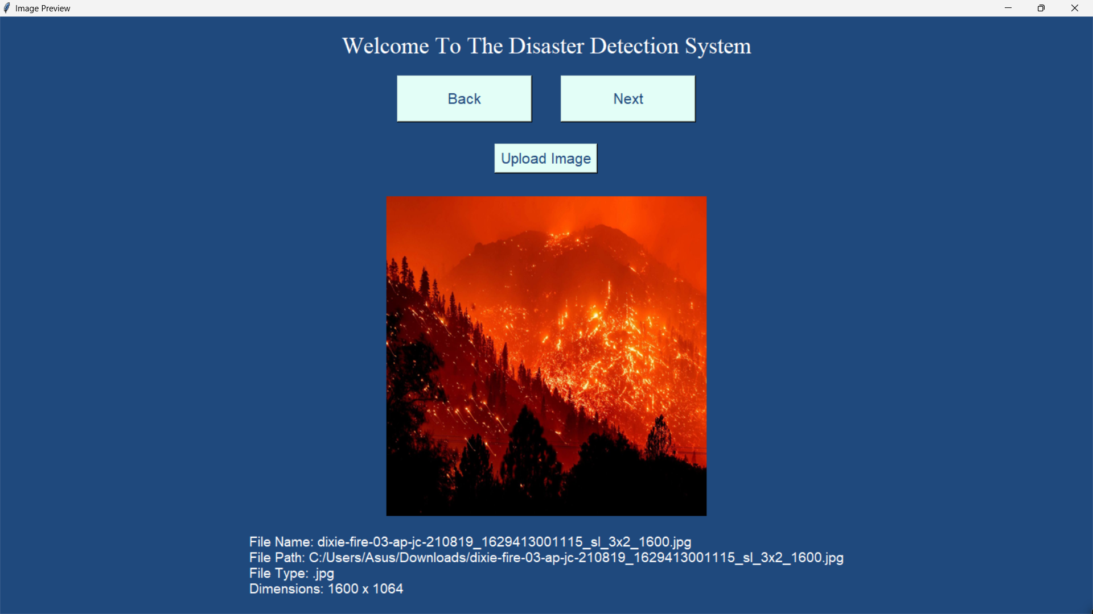

**Fig 8.5 Uploaded Image Details Screen**

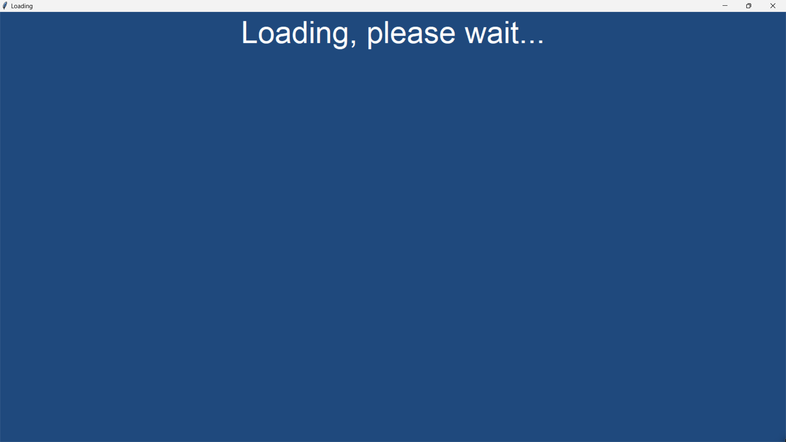

**Fig 8.5 Loading Screen**

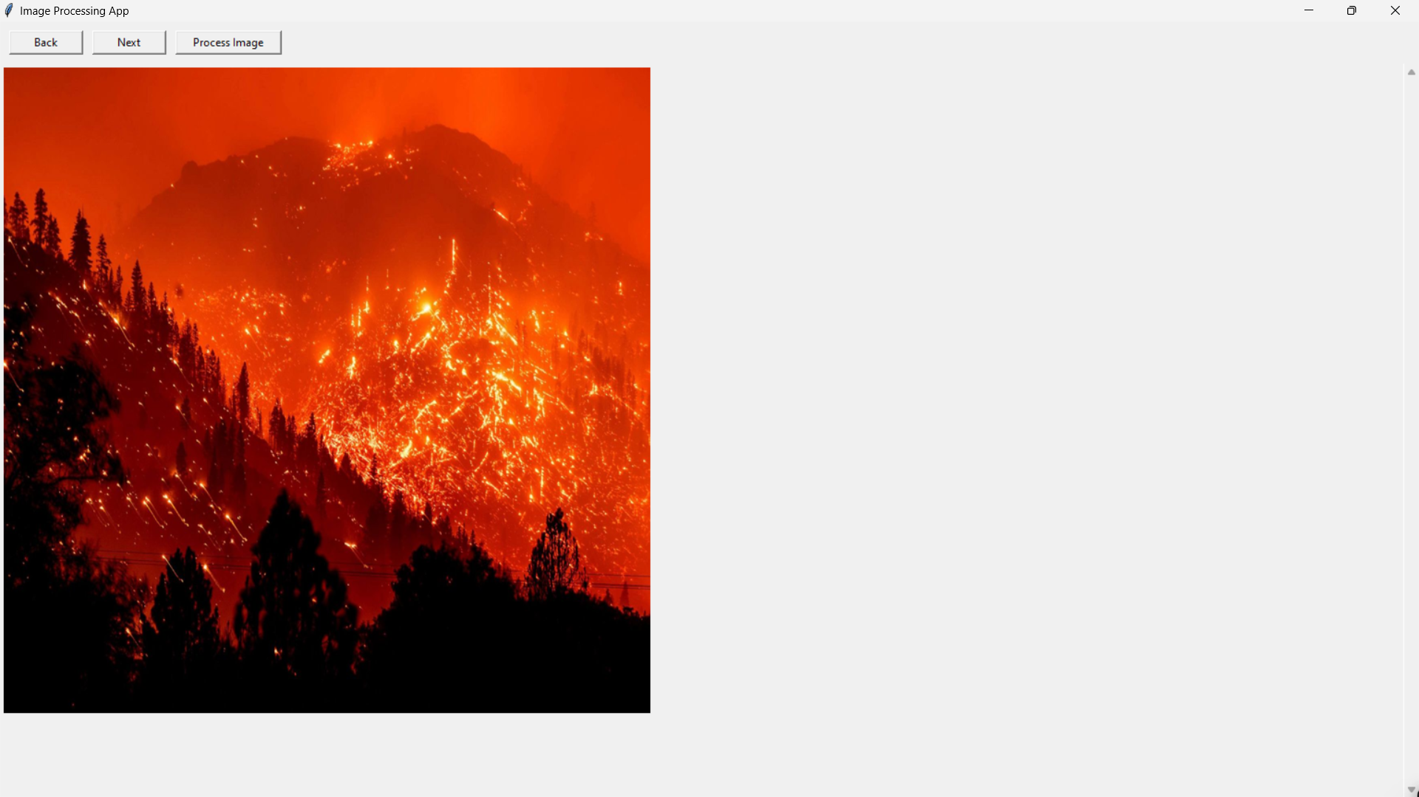

**Fig 8.6 Image Processing Screen**

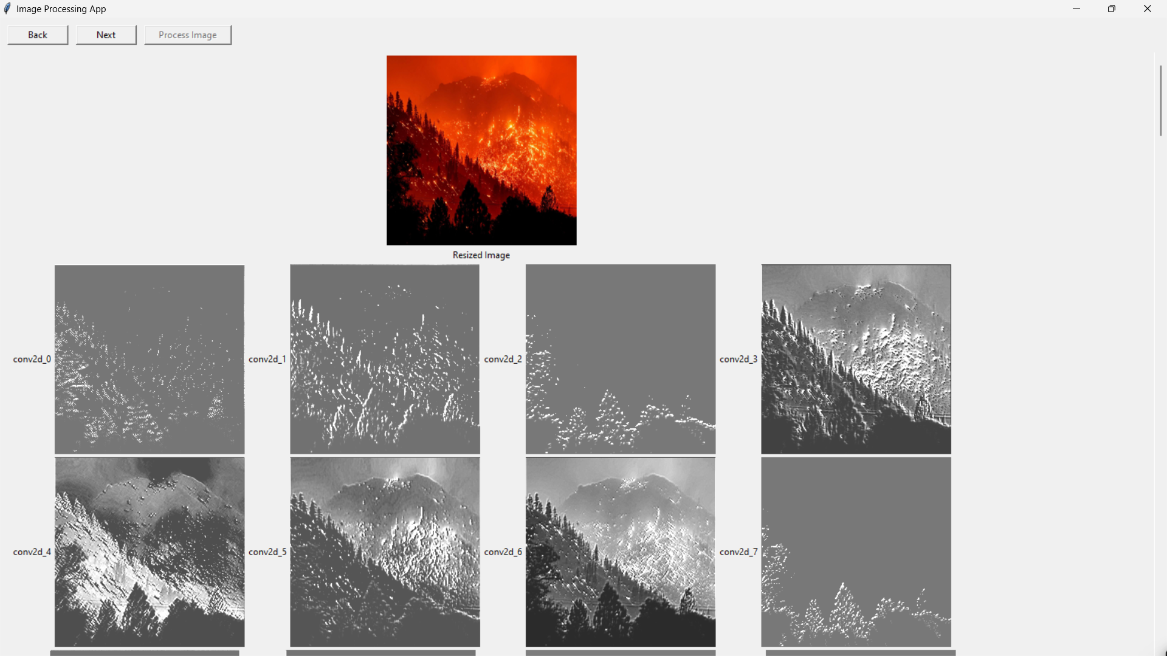

**Fig 8.6 Image Preprocessing in Detail Screens**

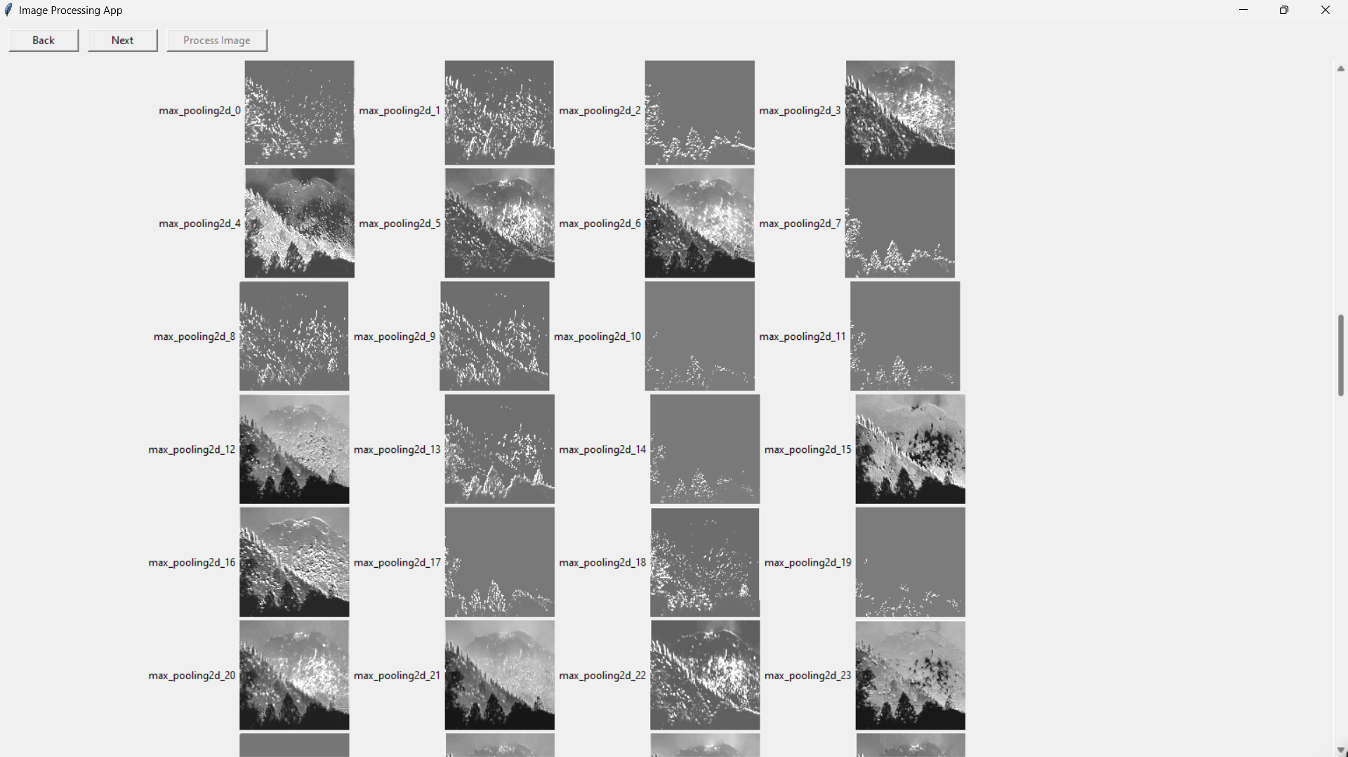

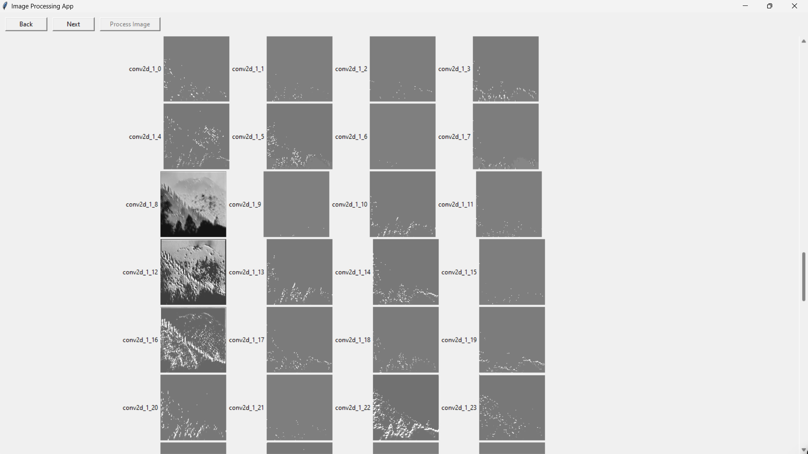

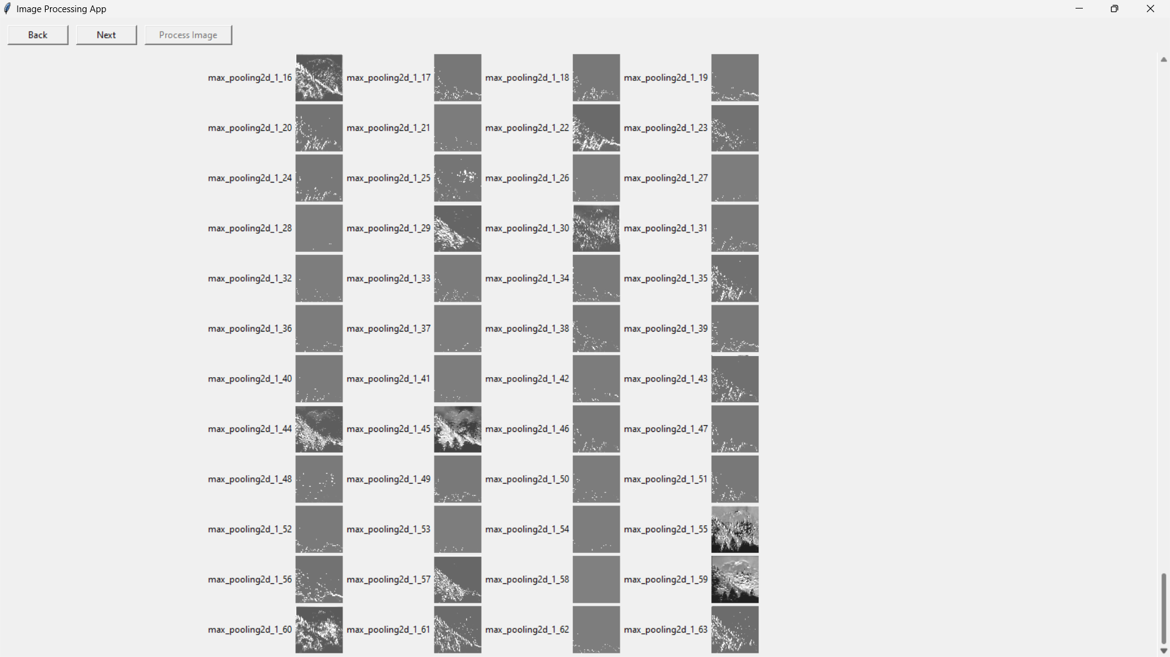

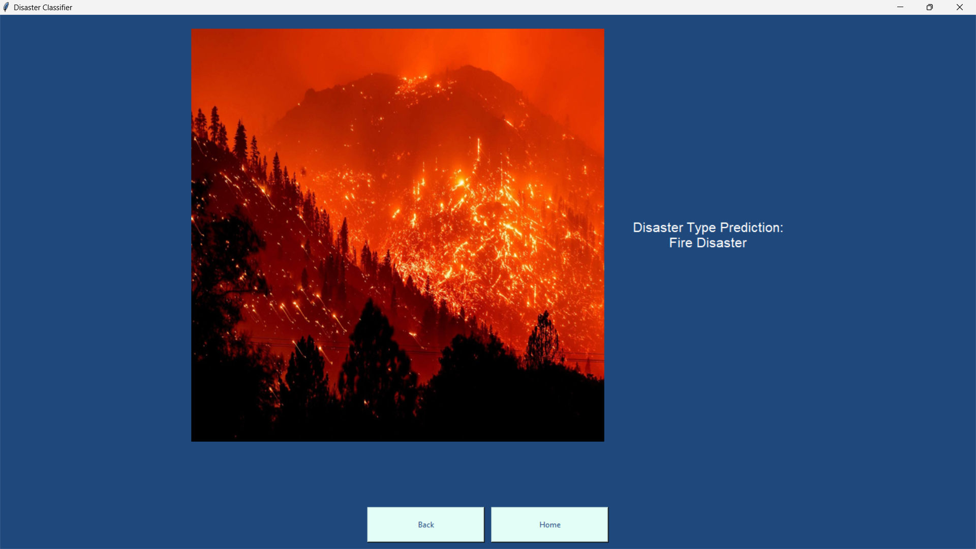

**Fig 8.7 Prediction Screen**

# 9.CONCLUSION

In conclusion, the Disaster Detection project marks a notable milestone in utilizing latest technologies to enhance monitoring disasters. By harnessing advanced models like Convolutional Neural Networks (CNNs) to analyze and categorize images, the project demonstrates a commitment to leveraging sophisticated algorithms for disaster detection.

The project‘s success can be attributed to its ability to adapt to intricate data patterns inherent in disaster scenarios. Through meticulous training and optimization, the CNNs employed in the project showcase a remarkable capacity to discern critical features of various types of disasters, enabling more accurate detection.

Moreover, the project addresses inherent limitations and challenges associated with traditional disaster detection methods by leveraging the power of deep learning. By overcoming these drawbacks, the project presents a robust and comprehensive solution that enhances the efficiency and effectiveness of disaster detection efforts.

Overall, the Disaster Detection project represents a significant step forward in the realm of disaster management, offering a sophisticated yet accessible tool for stakeholders involved in monitoring disasters. With its innovative approach and demonstrated effectiveness, the project sets a precedent for the integration of advanced technologies in disaster detection.

# 10.REFERENCE

1. Anisha Coopen and Sameerchand Pudaruth, ICT Department, FoICDT, University of Mauritius, Mauritius for Image Classification Based on Disaster type Using Deep Learning.
2. Indolia S, Goswami AK, Mishra SP, Asopa P (2018) Conceptual understanding of convolutional neural network—a deep learning approach. Procedia Comput Sci 132:679–688

[**Article**](https://doi.org/10.1016%2Fj.procs.2018.05.069)[**Google Scholar**](https://scholar.google.com/scholar_lookup?&title=Conceptual%20understanding%20of%20convolutional%20neural%20network%E2%80%94a%20deep%20learning%20approach&journal=Procedia%20Comput%20Sci&volume=132&pages=679-688&publication_year=2018&author=Indolia%2CS&author=Goswami%2CAK&author=Mishra%2CSP&author=Asopa%2CP)

1. Tang C, Zhu Q, Wu W et al (2020) PLANET: improved convolutional neural networks with image enhancement for image classification. Math Probl Eng 2020:1–10

[**Article**](https://doi.org/10.1155%2F2020%2F5892312)[**Google Scholar**](https://scholar.google.com/scholar_lookup?&title=PLANET%3A%20improved%20convolutional%20neural%20networks%20with%20image%20enhancement%20for%20image%20classification&journal=Math%20Probl%20Eng&volume=2020&pages=1-10&publication_year=2020&author=Tang%2CC&author=Zhu%2CQ&author=Wu%2CW)

1. Dharma LSA, Winarko E (2022) Classifying natural disaster tweet using a convolutional neural network and BERT embedding. In: 2022 2nd international conference on information technology and education (ICIT&E)

[**Google Scholar**](https://scholar.google.com/scholar?&q=Dharma%20LSA%2C%20Winarko%20E%20%282022%29%20Classifying%20natural%20disaster%20tweet%20using%20a%20convolutional%20neural%20network%20and%20BERT%20embedding.%20In%3A%202022%202nd%20international%20conference%20on%20information%20technology%20and%20education%20%28ICIT%26E%29)

1. Agrawal T, Suraj, Meleet M (2021) Classification of natural disaster using satellite & drone images with CNN using transfer learning. In: 2021 international conference on innovative computing, intelligent communication and smart electrical systems (ICSES)

[**Google Scholar**](https://scholar.google.com/scholar?&q=Agrawal%20T%2C%20Suraj%2C%20Meleet%20M%20%282021%29%20Classification%20of%20natural%20disaster%20using%20satellite%20%26%20drone%20images%20with%20CNN%20using%20transfer%20learning.%20In%3A%202021%20international%20conference%20on%20innovative%20computing%2C%20intelligent%20communication%20and%20smart%20electrical%20systems%20%28ICSES%29)

1. Sobhana M, Chaparala SC, Indira DNVSLS, Kumar KK (2022) A disaster classification application using convolutional neural network by performing data augmentation. IJEECS 27:1712

[**Google Scholar**](https://scholar.google.com/scholar?&q=Sobhana%20M%2C%20Chaparala%20SC%2C%20Indira%20DNVSLS%2C%20Kumar%20KK%20%282022%29%20A%20disaster%20classification%20application%20using%20convolutional%20neural%20network%20by%20performing%20data%20augmentation.%20IJEECS%2027%3A1712)

1. Weber E, Papadopoulos DP, Lapedriza A et al (2022) Incidents1M: a large-scale dataset of images with natural disasters, damage, and incidents

[**Google Scholar**](https://scholar.google.com/scholar?&q=Weber%20E%2C%20Papadopoulos%20DP%2C%20Lapedriza%20A%20et%20al%20%282022%29%20Incidents1M%3A%20a%20large-scale%20dataset%20of%20images%20with%20natural%20disasters%2C%20damage%2C%20and%20incidents)

1. 4DdiG Duplicate File Delete. <https://www.4ddig.net/>. Last accessed 2023/08/04
2. Image Deduplicator (Imagededup). <https://idealo.github.io/imagededup/>. Last accessed 2023/08/07
3. Du L, Ho ATS, Cong R (2020) Perceptual hashing for image authentication: a survey. Signal Process Image Communication 81:115713
4. Anisha Coopen and Sameerchand Pudaruth, ICT Department, FoICDT, University of Mauritius, Mauritius for Image Classification Based on Disaster type Using Deep Learning.

Gu J, Wang Z, Kuen J et al (2018) Recent advances in convolutional neural networks. Pattern Recognition 77:354–377

[**Article**](https://doi.org/10.1016%2Fj.patcog.2017.10.013)[**Google Scholar**](https://scholar.google.com/scholar_lookup?&title=Recent%20advances%20in%20convolutional%20neural%20networks&journal=Pattern%20Recogn&volume=77&pages=354-377&publication_year=2018&author=Gu%2CJ&author=Wang%2CZ&author=Kuen%2CJ)

1. "IBM Machine Learning using Python" offers a robust platform for mastering Python-based machine learning techniques with expert guidance from IBM.

[IBM Machine Learning Using Python](https://apps.cognitiveclass.ai/learning/course/course-v1:BDU+ML0101EN+v4/home)

1. The paper titled "A Comprehensive Review of Natural Language Processing Techniques for Sentiment Analysis in Social Media," available on Springer, offers an in-depth exploration of diverse natural language processing methodologies employed for sentiment analysis within social media platforms.

[Classification and Detection of Natural Disasters Using Machine Learning and Deep Learning Techniques](https://link.springer.com/article/10.1007/s12145-023-01205-2)

1. The "Disaster Images Dataset" on Kaggle, offers a curated collection of images depicting various disaster scenarios, serving as a valuable resource for research and analysis in disaster management and related fields. Researchers can leverage this dataset to develop and enhance algorithms for disaster detection.

[Kaggle Image Dataset](https://www.kaggle.com/datasets/varpit94/disaster-images-dataset)

**11. APPENDIX**

**11.1 List of Figures**

|  |  |  |
| --- | --- | --- |
| **Table number** | **Description** | **Page Number** |
| 4.3.1.1 | Sender And System Use Case | 43 |
| 4.3.1.2 | Disaster Detection System Use Case | 44 |
| 4.3.2.1 | User Scenario | 45 |
| 4.3.2.2 | System Scenario | 46 |
| 7.6.1 | Test Case: 1 | 85 |
| 7.6.2 | Test Case: 2 | 85 |

## 11.2 List of Figures

|  |  |  |
| --- | --- | --- |
| **Figure Number** | **Description** | **Page Number** |
| 1.2.4 | Machine Process Flow Diagram | 7 |
| 1.3.5 | CNN Process Flow | 15 |
| 4.3.1.1 | Use Case Diagram | 43 |
| 4.3.3.1 | Sequence Diagram for User | 46 |
| 4.3.3.2 | Sequence Diagram for System | 47 |
| 4.3.4 | Activity Diagram | 49 |
| 8.1 | Home Screen | 86 |
| 8.2 | Abstract Screen | 86 |
| 8.3 | Help Screen | 87 |
| 8.4 | Load Model Screen | 87 |
| 8.4 | Load Model Selecting Screen | 88 |
| 8.4 | Model Loaded Successfully Screen | 88 |
| 8.5 | Upload Image Screen | 89 |
| 8.5 | Selecting Image Screen | 89 |
| 8.5 | Uploaded Image Details Screen | 90 |
| 8.5 | Image Processing Screen | 91 |
| 8.6 | Image Preprocessing Screens | 91 |
| 8.7 | Prediction Screen | 93 |